# Basic intro1

1. What is Docker

2. Virtual Machines vs. Docker

3. Introduction to Dockerfiles, images and containers

4. The Docker Hub

5. Writing a Dockerfile

6. Building an image

7. Running a container

8. Mounting volumes

9. One process per container

REF: <https://youtu.be/YFl2mCHdv24>

CONTAINER: is a running instance of an IMAGE

IMAGE - template for creating environment you wanted to run (its snapshot), a ‘package template plan’.

image: has OS, software, application code.

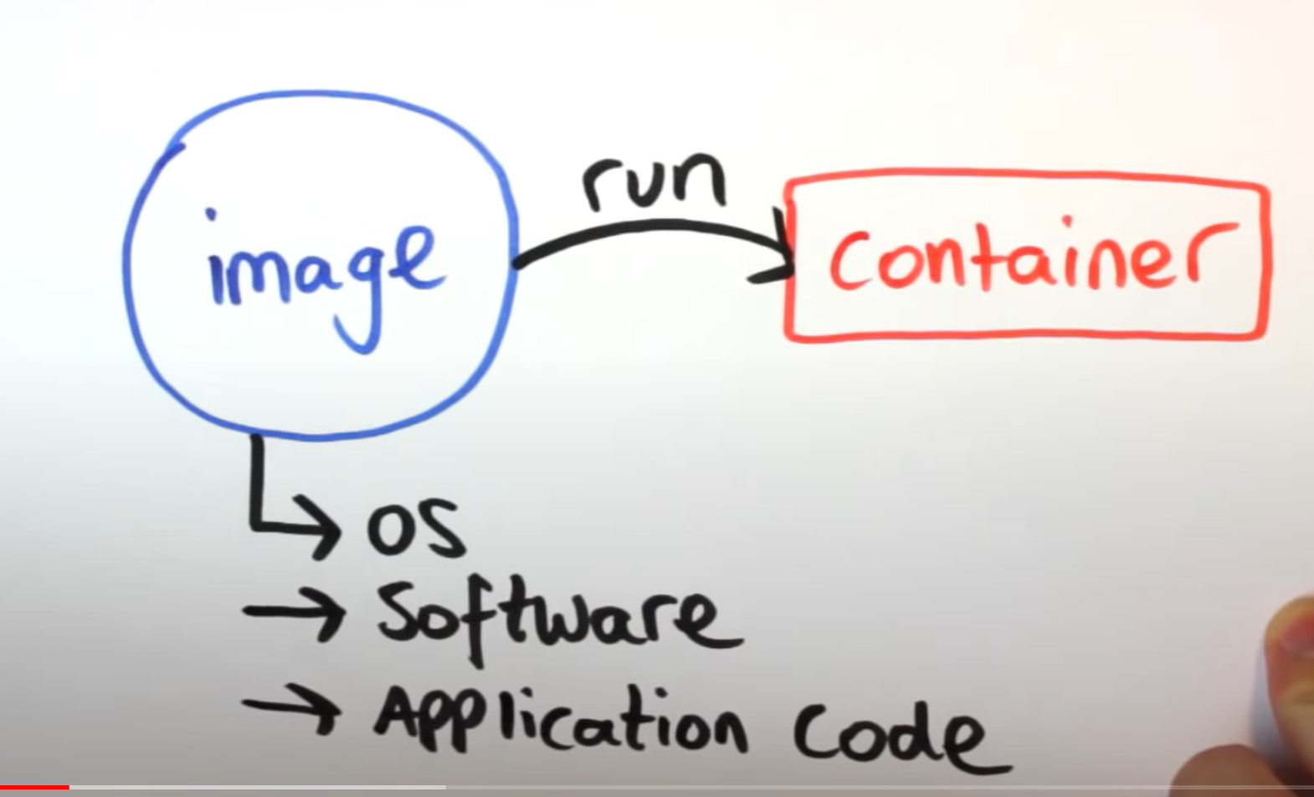

Images are 'defined' using DOCKERFILE (a text file), with a list of steps to perform, to create that image.

Use 'Dockerfile' to build the 'Image', which is run to get 'Container'.

-p for forward port 80 on host (the computer) to port 80 in container ().

-- " docker run -p 80:80 <container_name> "

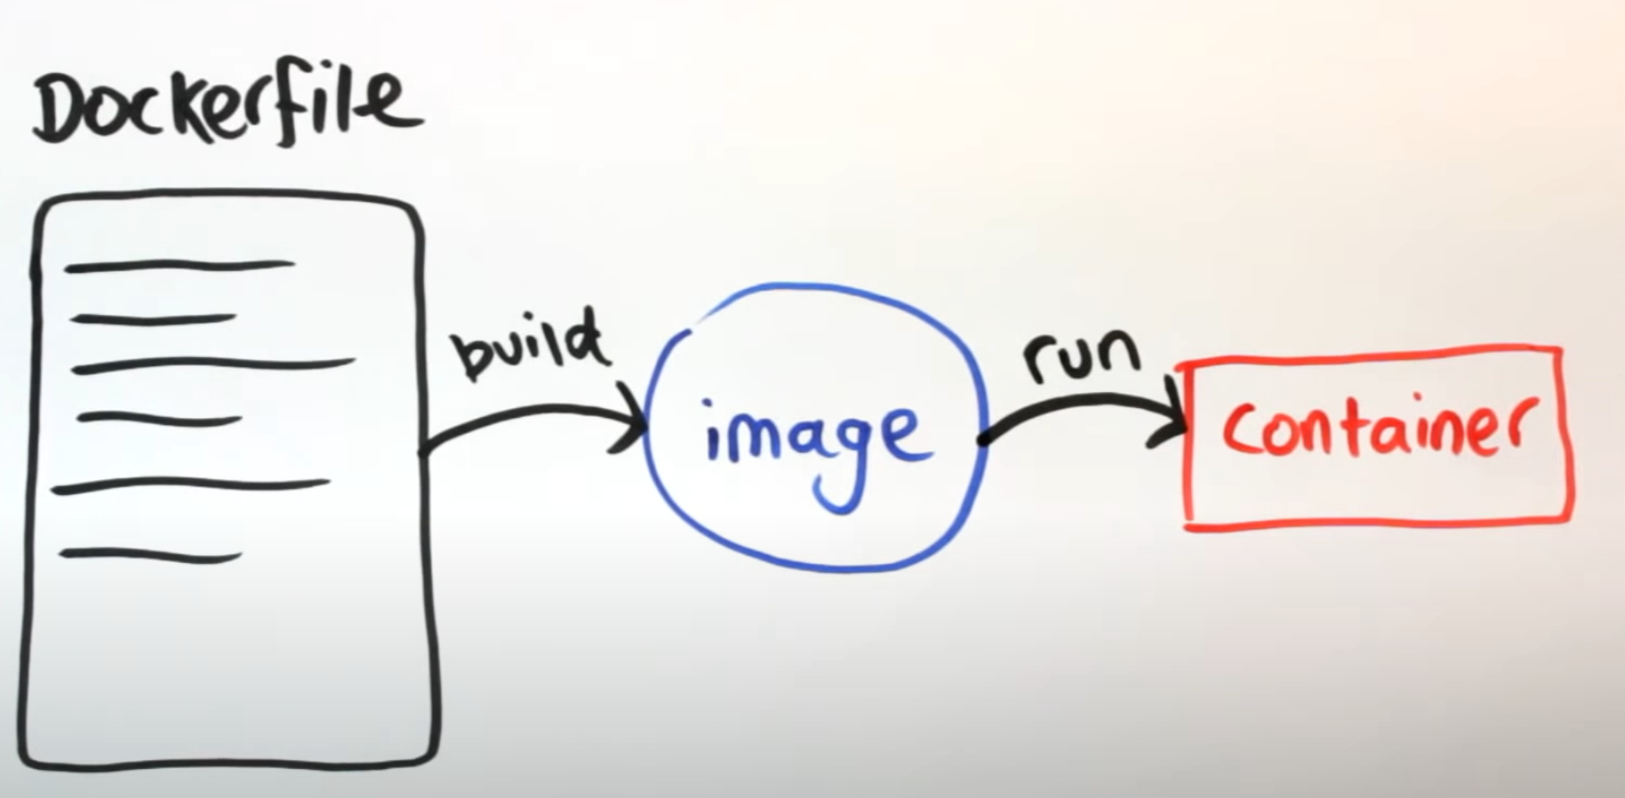

- to reflect changes made: rebuild the image and spin up new container from updated image

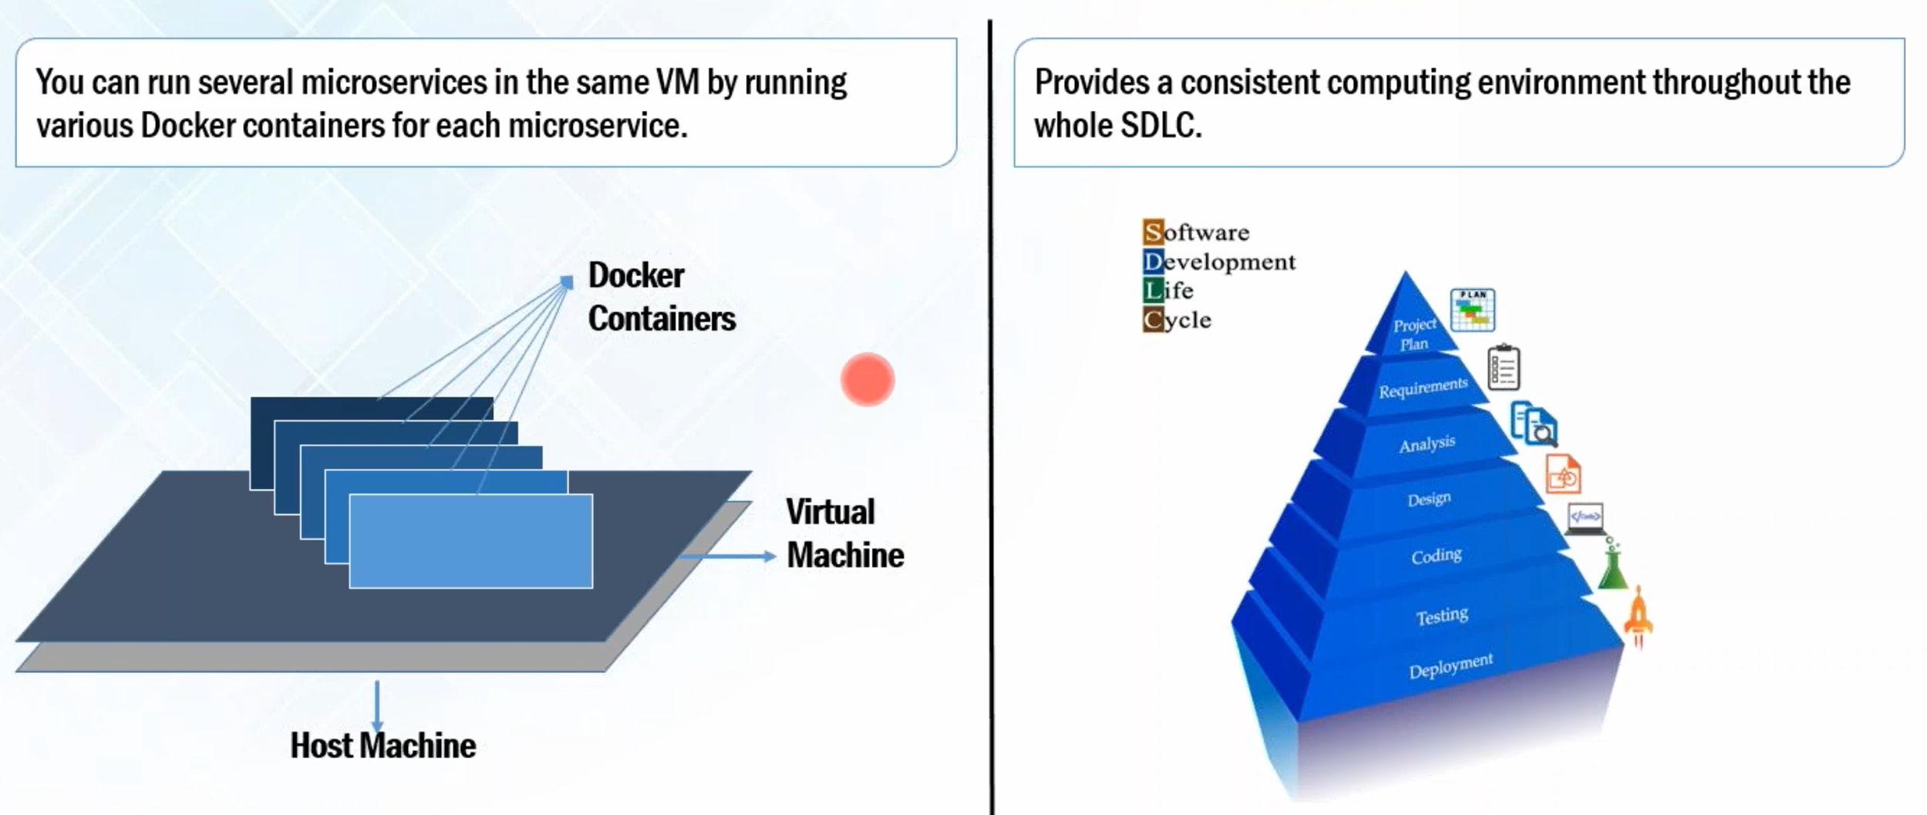

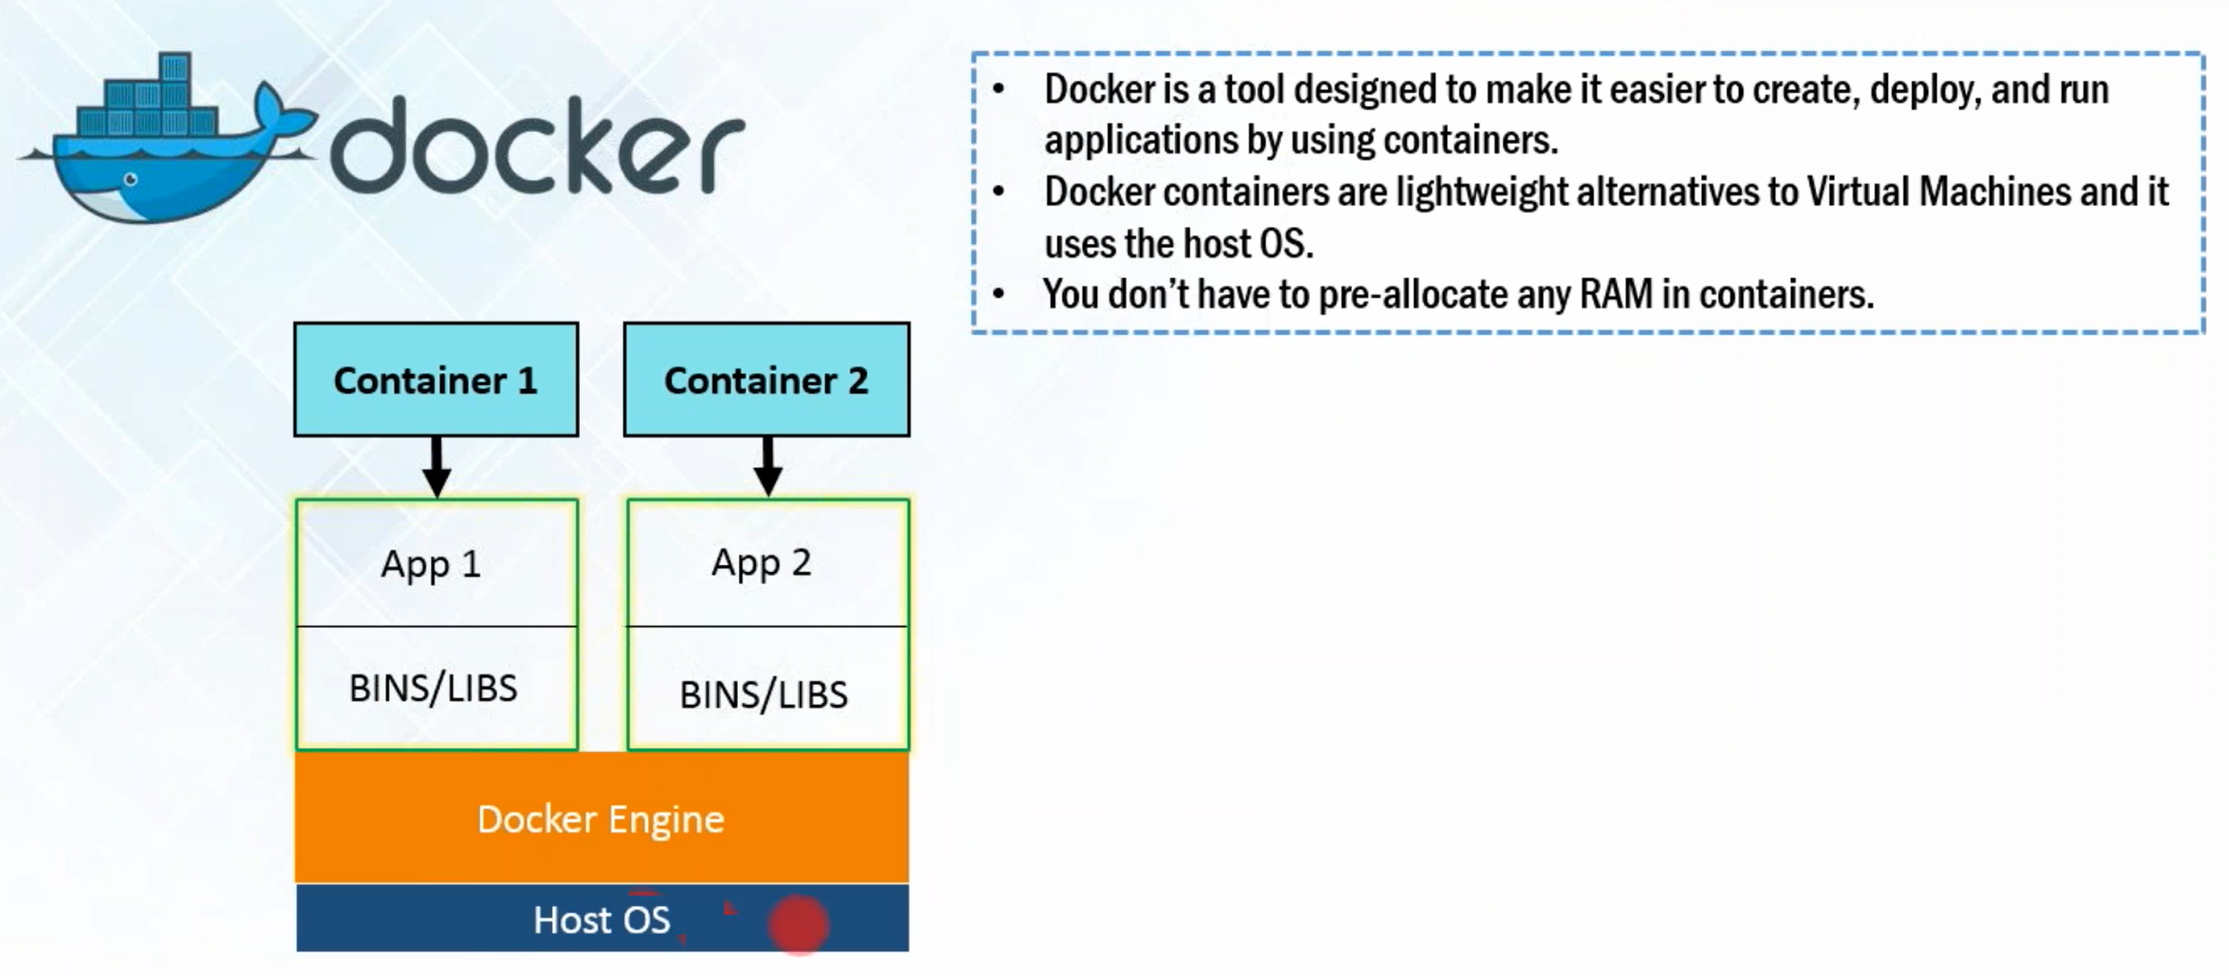

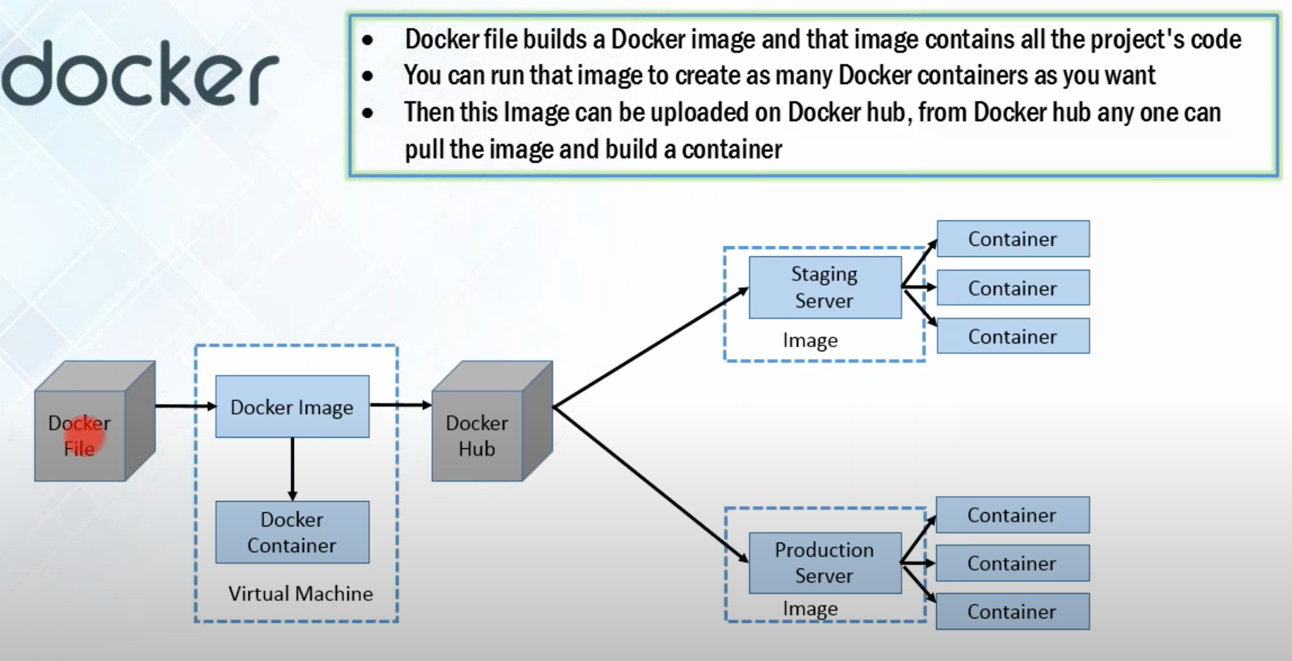

Another Docker Example:

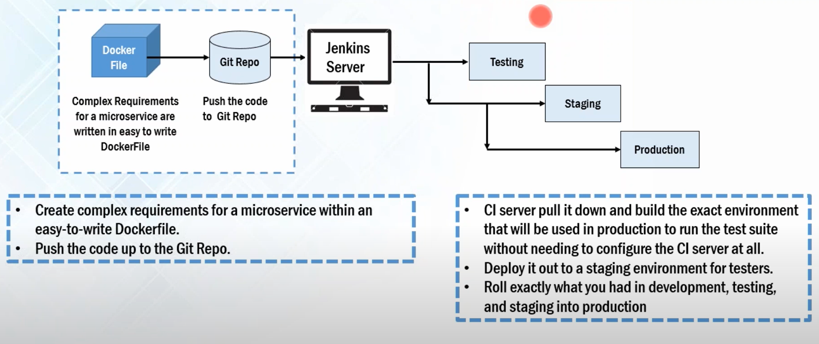

Case study example:

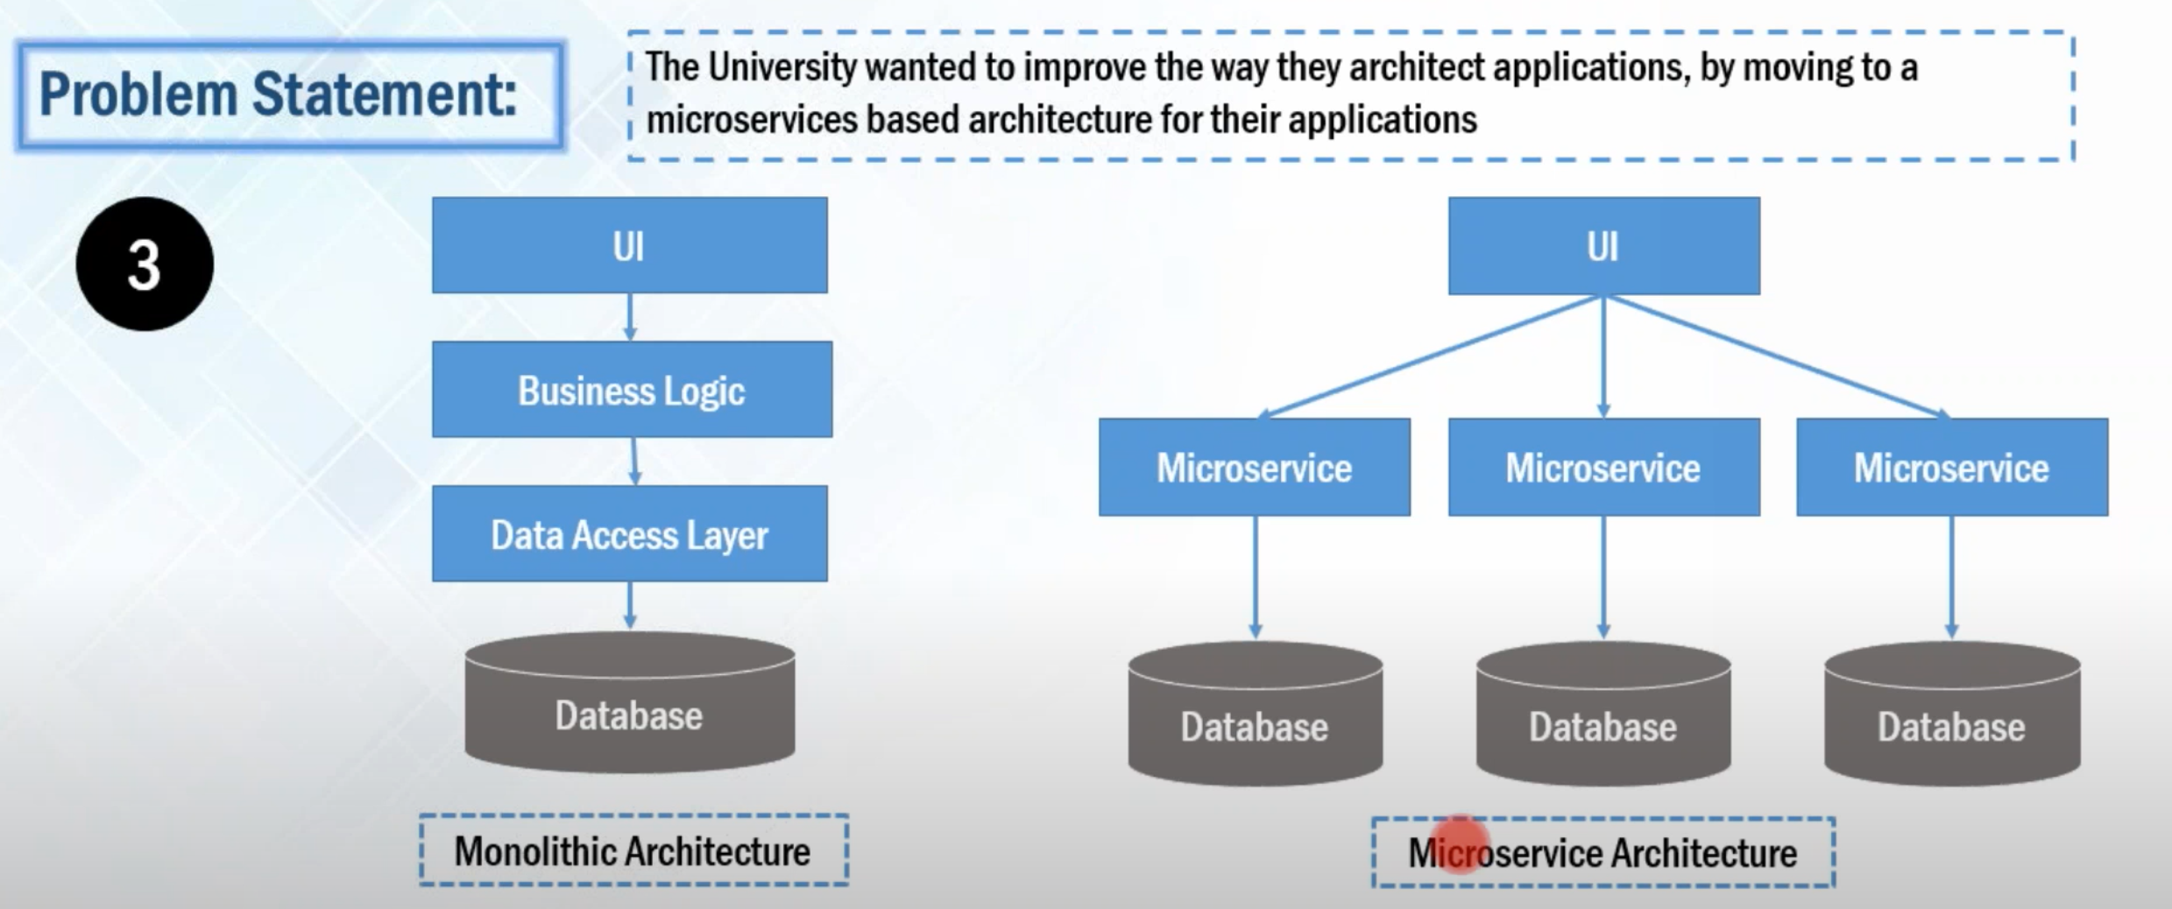

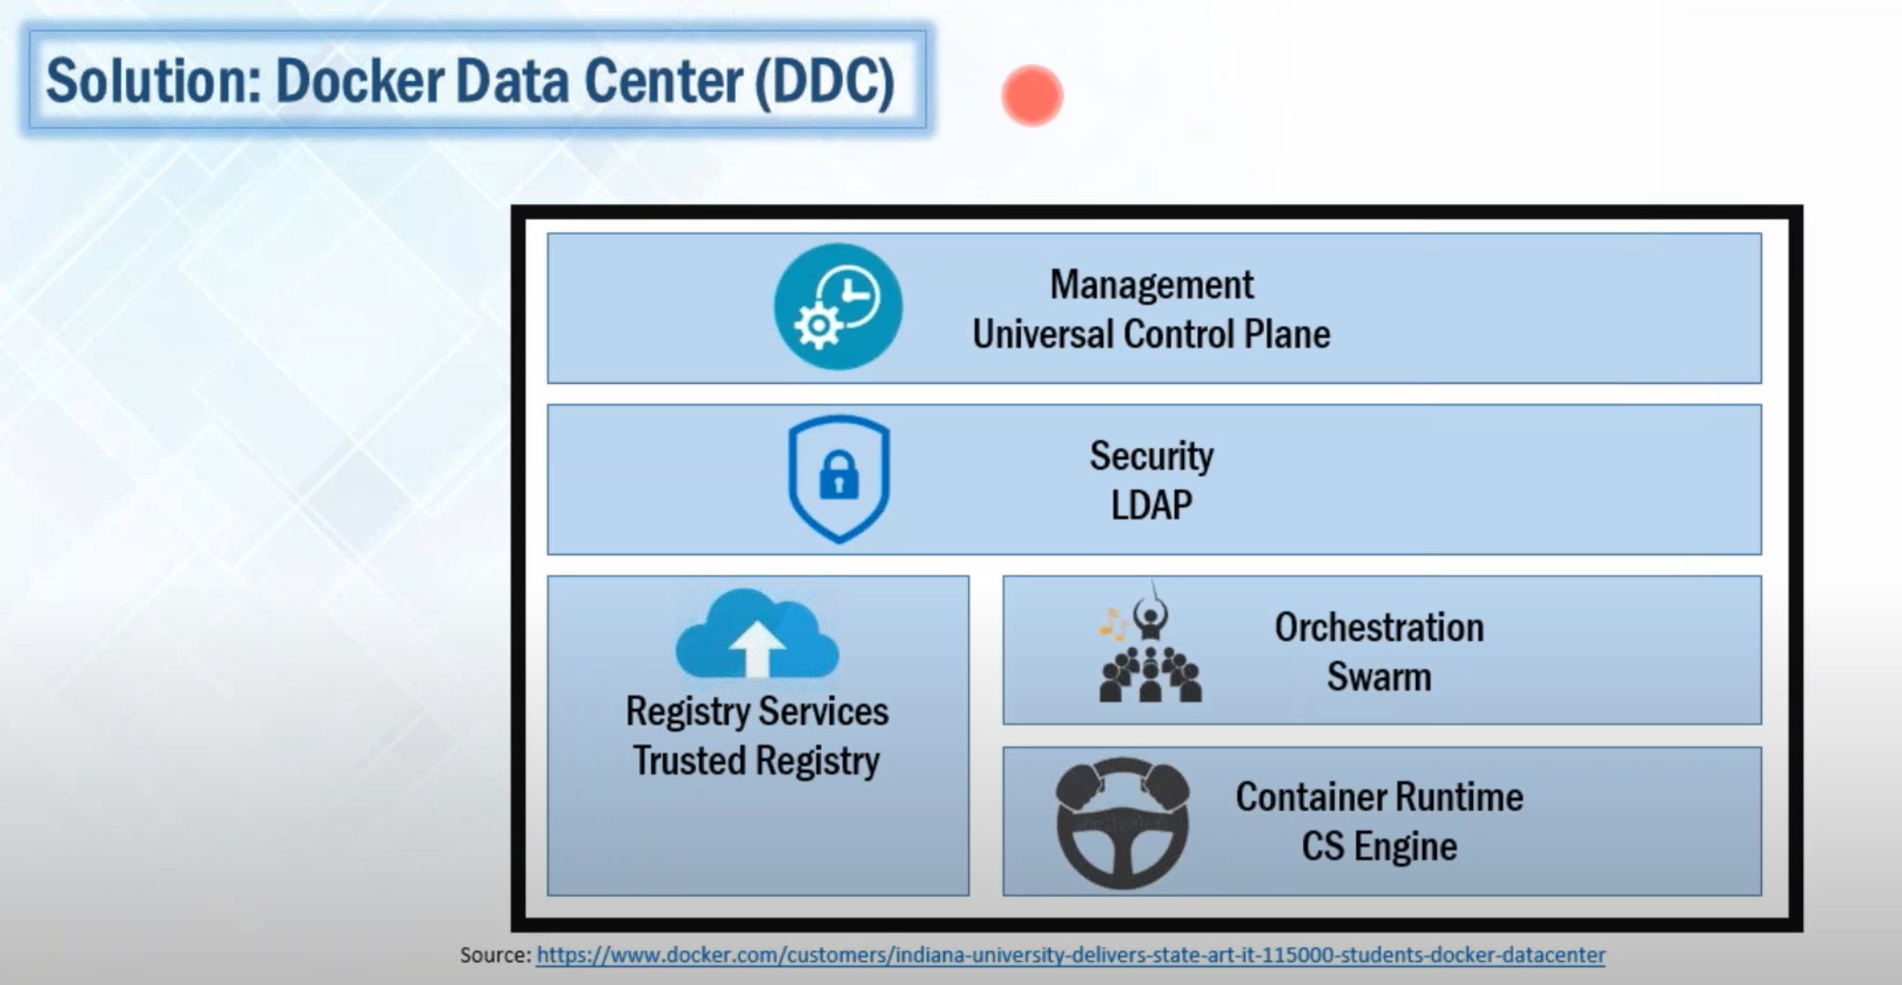

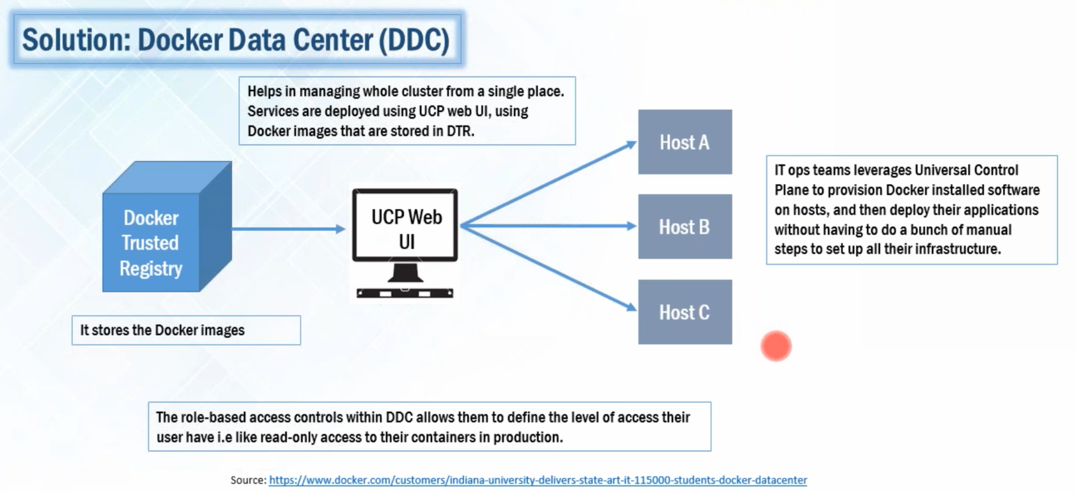

## DOCKER COMPONENTS:

Docker Registry:

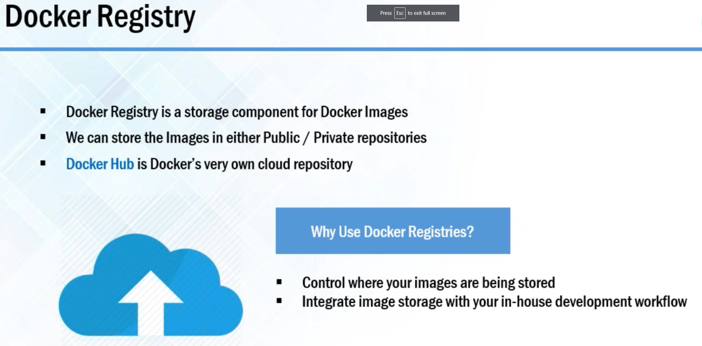

Docker Hub:

Docker Images:

Docker Containers:

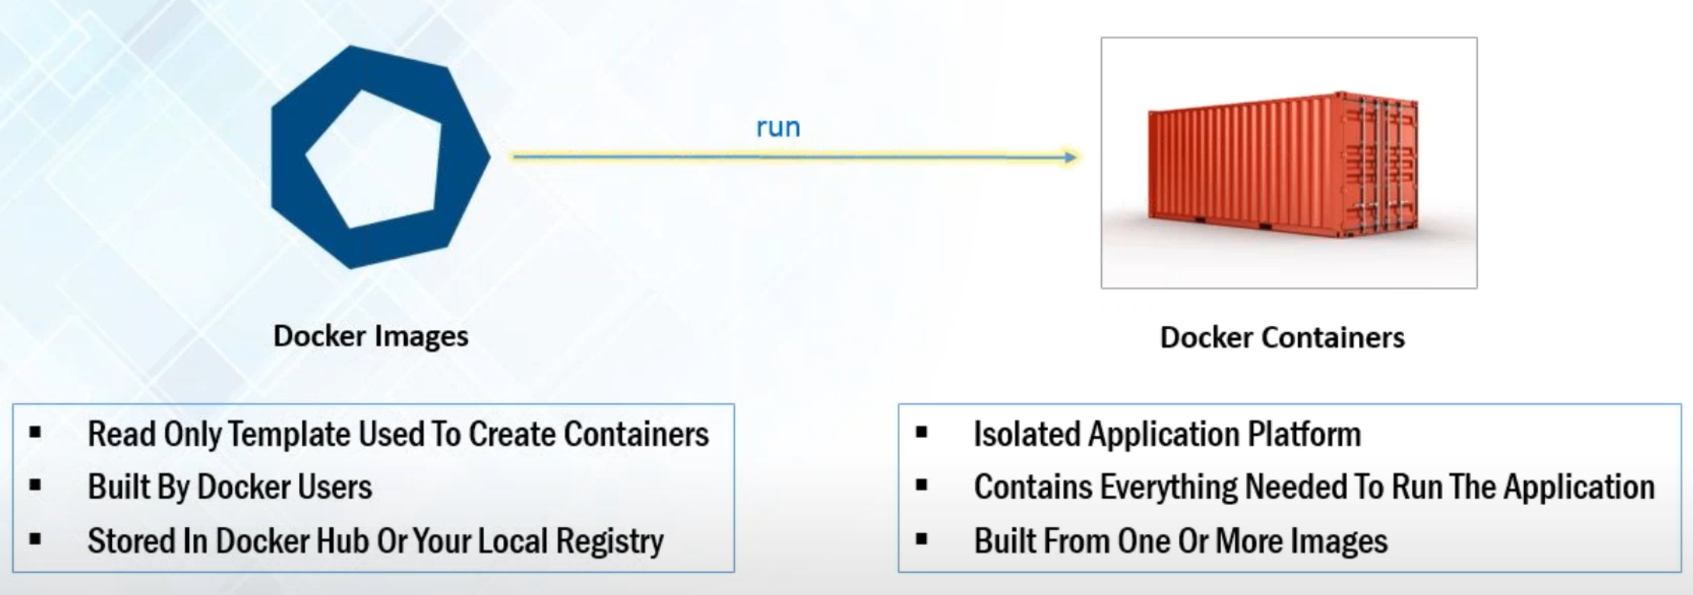

**## Deviation**

STEPS:

Start docker server”

Cmd: “ sudo service docker start ”

Pull (centos) image from docker hub:

Cmd: “ sudo docker pull centos ”

Run (centos) container:

Cmd: “ sudo docker run -it centos ”

Exit container:

Cmd: “ exit ”

**##**

Docker Compose:

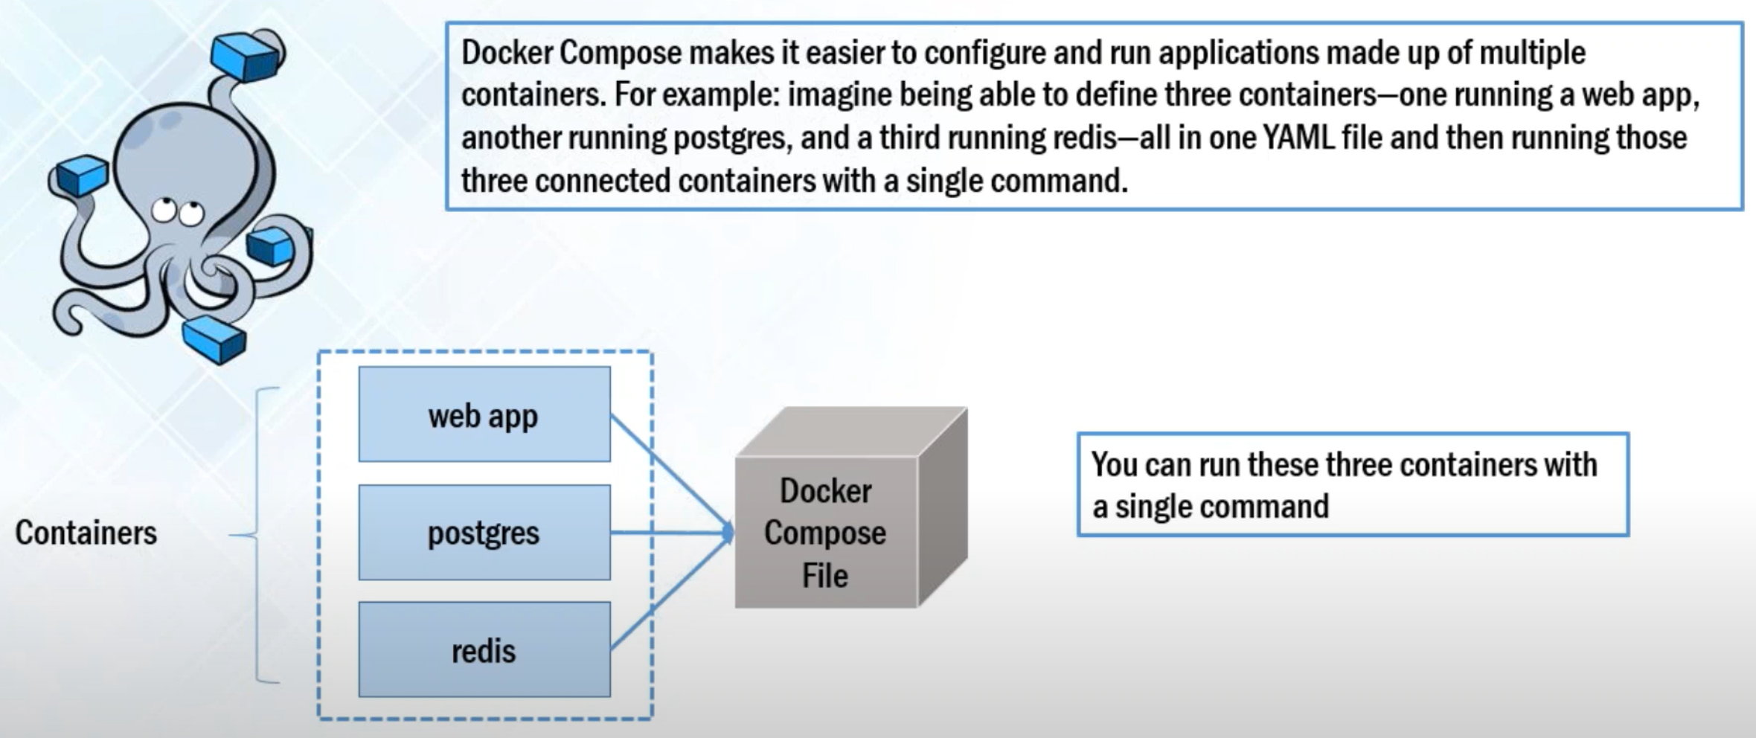

Cmd use of compose steps:

“ sudo apt-get install python-pip ”

“ sudo pip install docker-compose ”

Make a directory named wordpress:

“ mkdir wordpress ”

“ cd wordpress/ “

Edit yml file using gedit:

“ sudo gedit docker -compose.yml ”

Open a new doc and copy the yml code, and paste it into the docker-compose.yml file.

**While linking containers the word after colon , i.e., “mysql” is the name we give.

“ sudo docker-compose up -d ” - this will pull 3 images and build containers.

“ ”

REF: <https://youtu.be/lcQfQRDAMpQ?t=1509>

#######################################################################

===============================================================

# Kodekloud youtube: Full basic Docker course:

REF: <https://youtu.be/zJ6WbK9zFpI>

Docker For Beginners

[2:37](https://www.youtube.com/watch?v=zJ6WbK9zFpI&t=157s) Docker Overview

[16:55](https://www.youtube.com/watch?v=zJ6WbK9zFpI&t=1015s) Docker Installation

[20:00](https://www.youtube.com/watch?v=zJ6WbK9zFpI&t=1200s) Docker Commands

[42:06](https://www.youtube.com/watch?v=zJ6WbK9zFpI&t=2526s) Docker Environment variables

[44:05](https://www.youtube.com/watch?v=zJ6WbK9zFpI&t=2645s) Docker Images

[51:36](https://www.youtube.com/watch?v=zJ6WbK9zFpI&t=3096s) Docker CMD vs Entrypoint

[58:30](https://www.youtube.com/watch?v=zJ6WbK9zFpI&t=3510s) Docker Networking

[1:03:57](https://www.youtube.com/watch?v=zJ6WbK9zFpI&t=3837s) Docker Storage

[1:16:19](https://www.youtube.com/watch?v=zJ6WbK9zFpI&t=4579s) Docker Compose

[1:34:39](https://www.youtube.com/watch?v=zJ6WbK9zFpI&t=5679s) Docker Registry

[1:39:30](https://www.youtube.com/watch?v=zJ6WbK9zFpI&t=5970s) Docker Engine

[1:46:06](https://www.youtube.com/watch?v=zJ6WbK9zFpI&t=6366s) Docker on Windows

[1:52:06](https://www.youtube.com/watch?v=zJ6WbK9zFpI&t=6726s) Docker on Mac

[1:54:39](https://www.youtube.com/watch?v=zJ6WbK9zFpI&t=6879s) Container Orchestration

[1:58:53](https://www.youtube.com/watch?v=zJ6WbK9zFpI&t=7133s) Docker Swarm

[02:02:35](https://www.youtube.com/watch?v=zJ6WbK9zFpI&t=7355s) Kubernetes

[2:08:40](https://www.youtube.com/watch?v=zJ6WbK9zFpI&t=7720s) Conclusion

The 2 can be used together in integration:

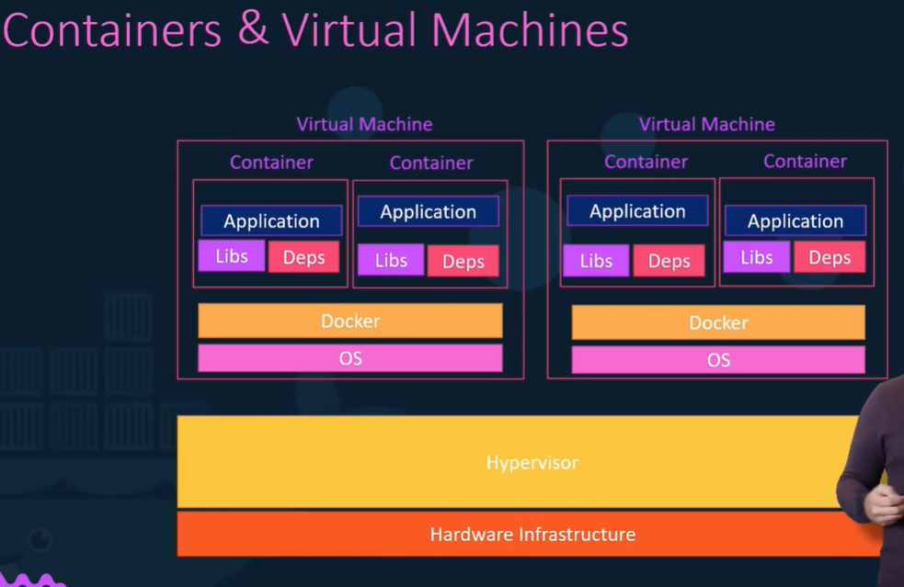

## DOCKER COMMANDS:

**run** - will run a container , either by using local image or pulling it from hub.

**ps** - list all running containers. Eg: “ docker ps ”

To see all containers: “ docker ps -a ”

**stop** - stop a container. Used with container name. Eg: “ docker stop silly_sammer “

**rm** - remove an exited or stopped container permanently.

**images** - list all images.eg: “ docker images ”

**rmi** - remove an image. Eg: “ docker rmi nginx ”

**Make sure to delete all dependent containers in order to remove/delete an image!

**pull** - to only pull/download an image (and not run). Eg: “ docker pull nginx ”

**A container only lives as long as the process inside it is alive.

Eg: If the service inside the container dies/closes/crashes, then the container ‘exists’.

**exec** - Execute a command on a running docker container.

**-d** - Run docker container in ‘detach’ mode. Eg: “ docker run -d thefolder/simple-webapp ”

**run the ‘*docker ps’* command to view the container.

**attach** - to attach to a running (detached) container. Eg: “ docker attach name/ID_of_container ”

**can only just provide the first few chars. of the ID of container, in case of ID.

**Then can use “ control+C” to detach.

tag -

Eg: Specifying version: “ docker run redis:4.0 ”

Default tag is always “ :latest ”

** IMP: by default docker doesn’t listen to STDIN.

**-i** - for interactive mode. Eg: “ docker run -i my_folder/simple-prompt-docker ”

**-t** - stands for sudo terminal (to get the prompt as well). Eg: “ docker run -it my_folder/simple-prompt-docker ” - attached to terminal and in interactive mode.

**Port Mapping**:

The underlying host is called docker host or docker engine. We run a contain

What IP to use to access the app running in docker container (listening on port, say, 5000) from a web browser?

2 options:

1)

To use IP of the docker container. Every docker container gets an IP assigned by default. This is an internal IP and only accessible within the docker host.

To access we can use the IP of the docker host. For that to work, the port inside the Docker container should be mapped to a free port on the docker host.

Port mapping - “ docker run -p 80:5000 my_folder/simple-prompt-docker ”

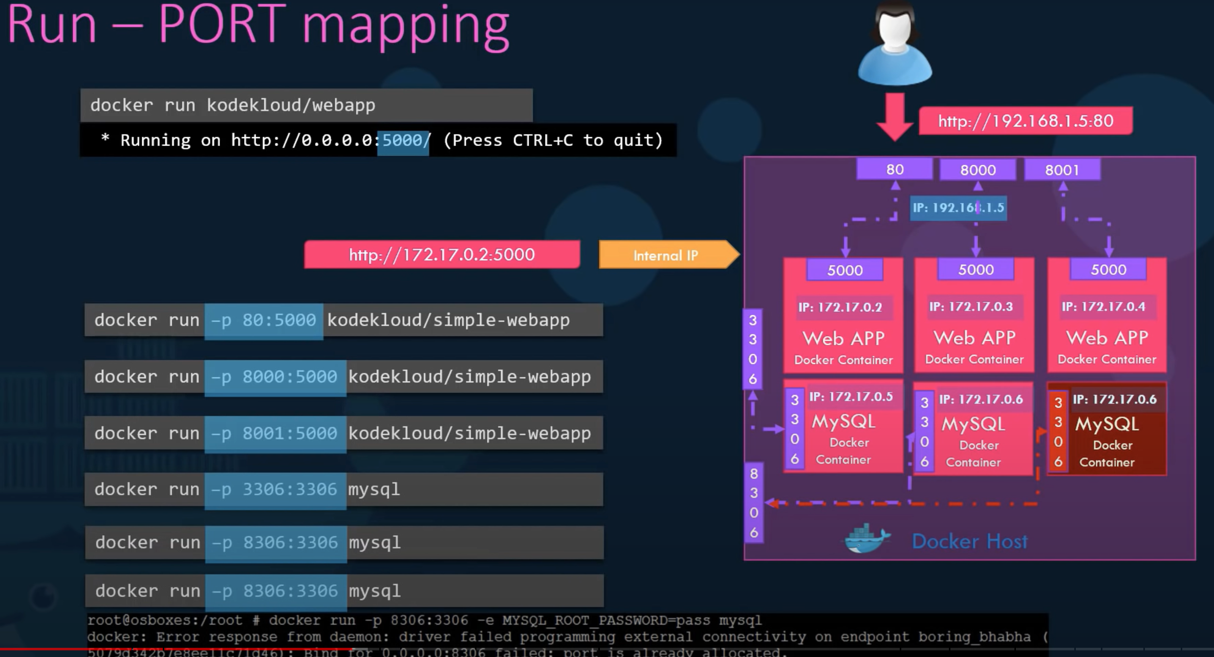

**VOLUME MAPPING**: how data is persisted in a container.

Docker container has its own isolated file system. Located at: “ /var/lib/container_name “

If the Container is deleted, all stored data there is gone.

To keep the data persistent after container is deleted, map a dir outside the container on docker host to a dir inside container.

**-v** - “ docker run -v *dir_on_docker_host*:*dir_inside_docker_container docker_container* ”

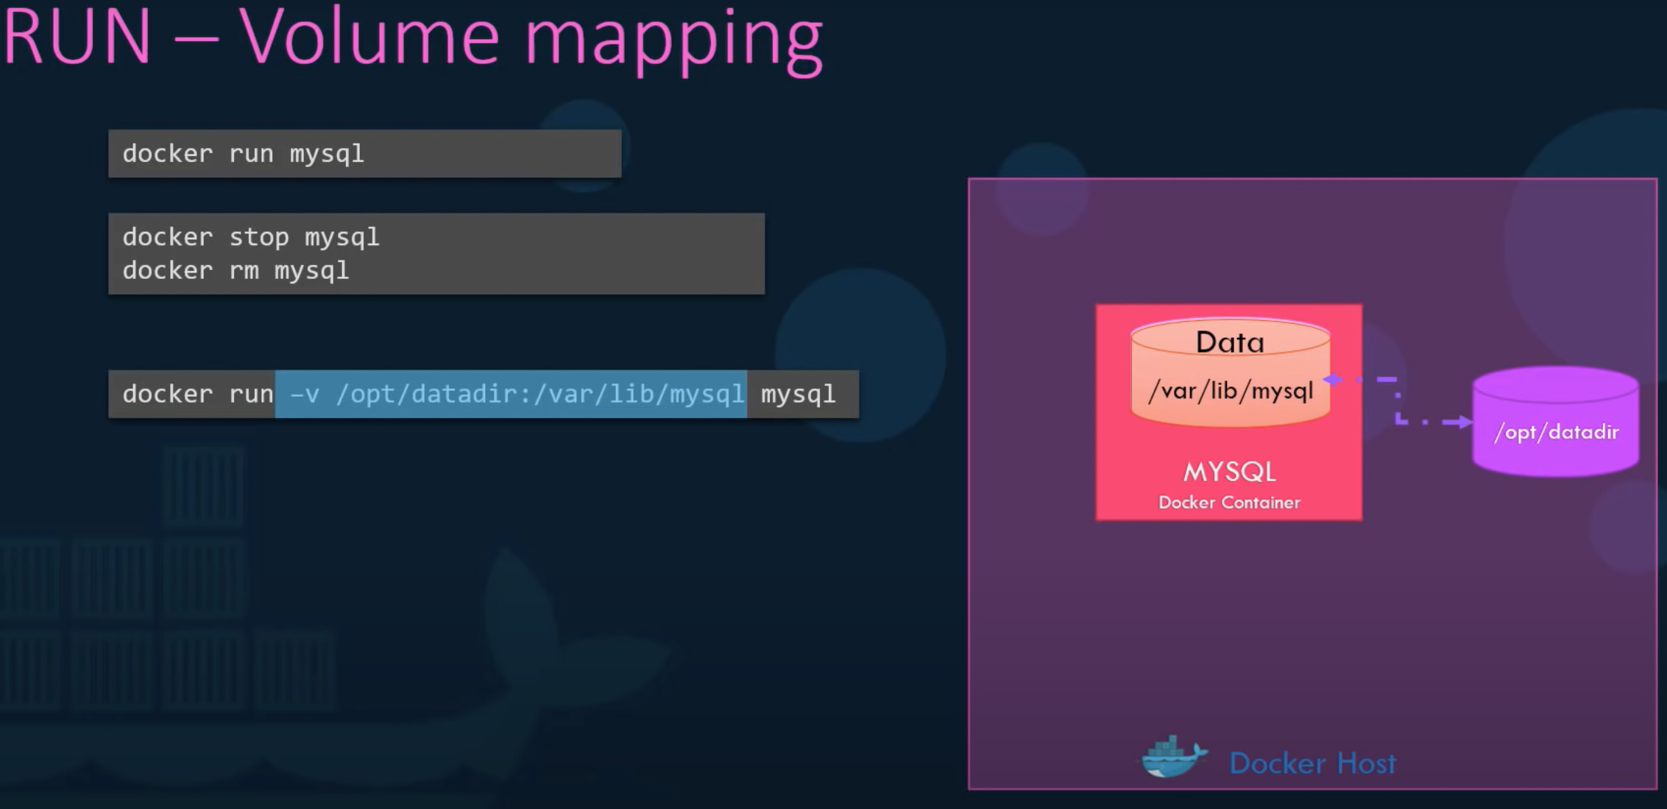

**Inspect** Container: see additional details of container.

“ docker inspect *container_name* ” : returns all details in json format.

Container **Logs**:

“ docker logs *container_name* ”

-----------------------------------------------------------------------------------------------------

## Docker Environment Variables:

**-e** -

Environment variables are found under the “config” section on the json return from the inspect container command.

Assign variable to a system variable: “ color = os.environ.get(‘APP_COLOR’) ” then

“ docker run -e APP_COLOR=blue *container_name* ”

------------------------------------------------------------------------------------

## Docker IMAGES:

How to create an Image?:

Manual broad steps for deployment:

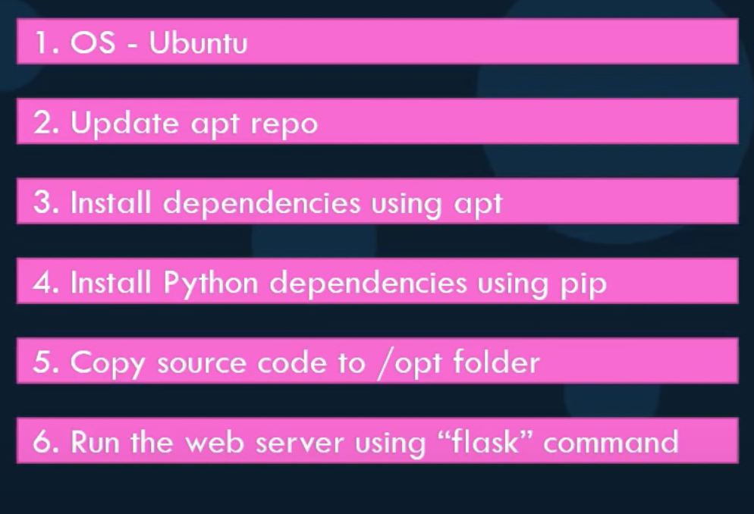

DOCKERFILE:

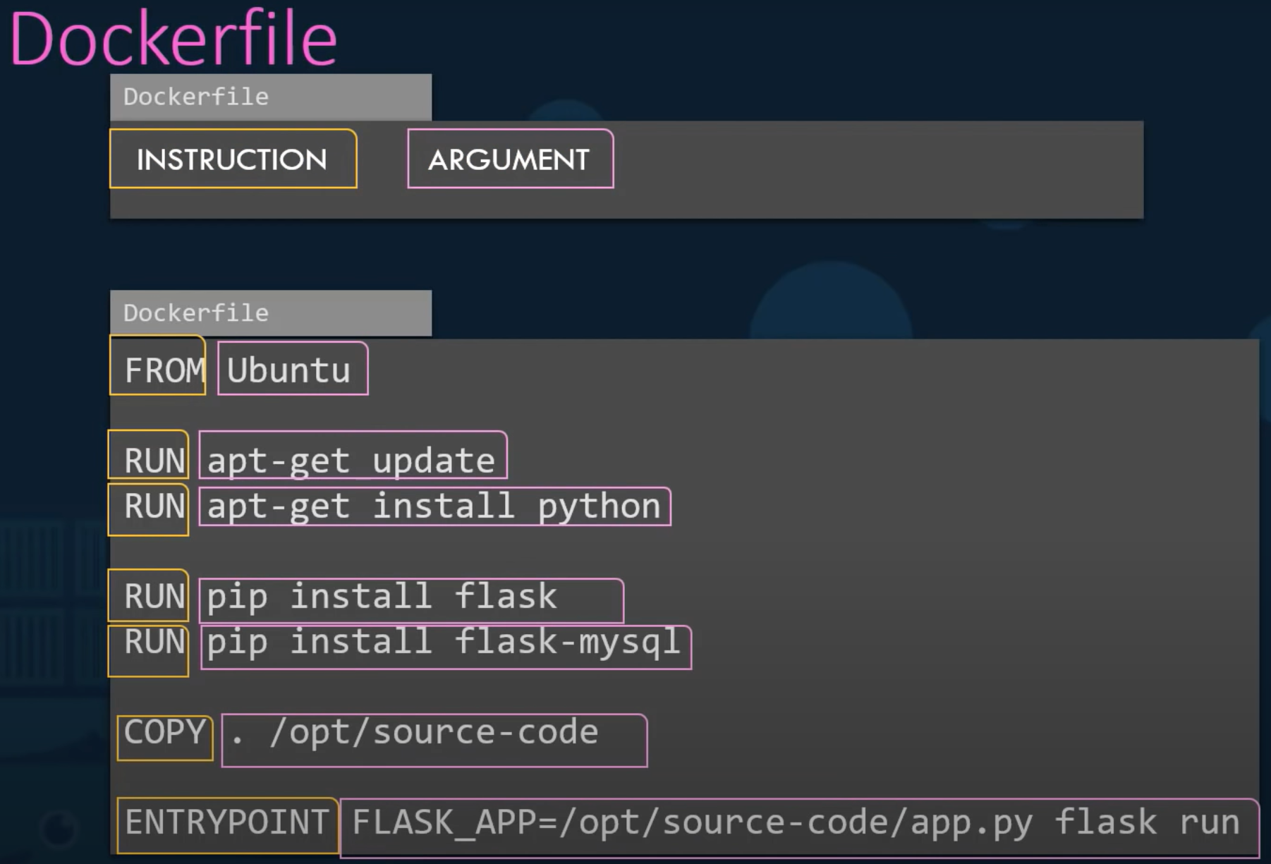

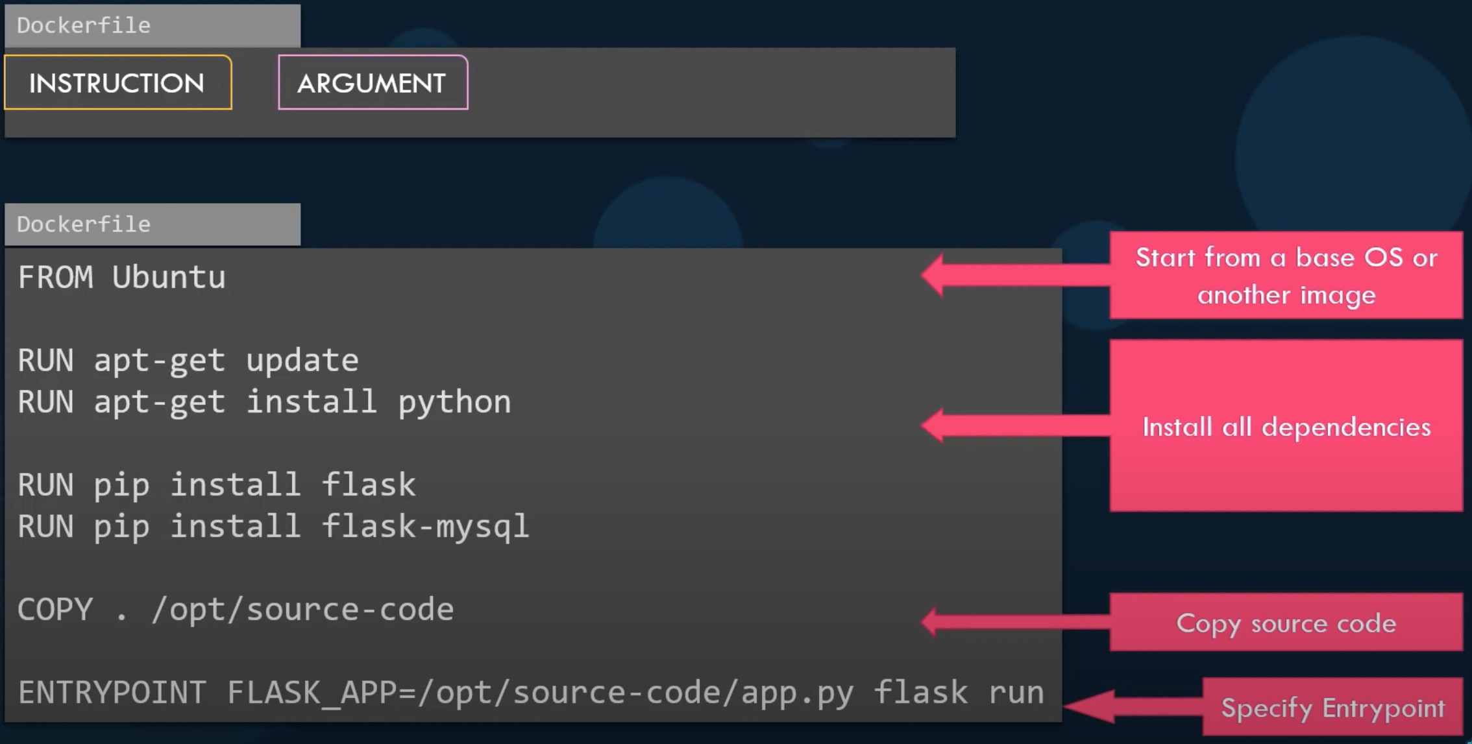

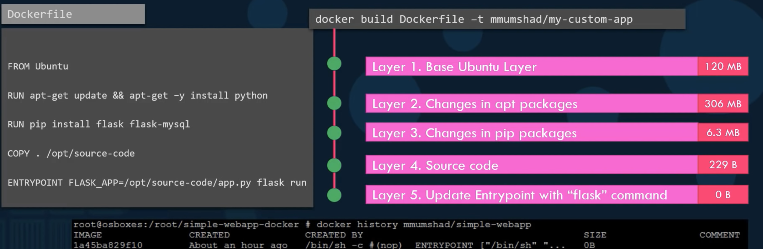

Its build in layer on to of layer format.

Failure of any particular layer: it rebuilds the remainder of layers from using previous layers from cache.

-----------------------------------------------------------------------------------------------------------------

## CMD vs ENTRYPOINT:

Who defines what process is run inside a container?

** BASH: bash is not exactly a ‘process’ like a web server or DB server. It is a ‘shell’ that listens for input from a terminal. If it cannot find a terminal, it exits.

By default, docker doesn’t attach a terminal to a container when it is run.

How to specify a different command to start a container than the default CMD (containing bash).?

One way: append a command to docker run to override the default one.

“ docker run ubuntu *[COMMAND]* ” . eg: “ docker run ubuntu sleep 5 ”

Next, how to make this change permanent?

Create own image from base image (eg: base ubuntu image)

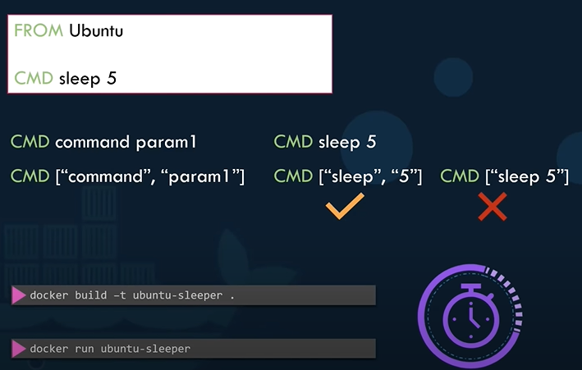

How to change the parameter of the *sleep* command, say?

One way is to change value while calling:

“ docker run ubuntu-sleeper sleep 10 ”

Using ‘Entrypoint’ instructions:

In case of CMD, commandline params passed will be replaced entirely, while in case of ‘entrypoint’ the commandline params will get appended.

How to configure a default value for the command: use both, CMD and ENTRYPOINT.

If we still wanna change, it can be overwritten.

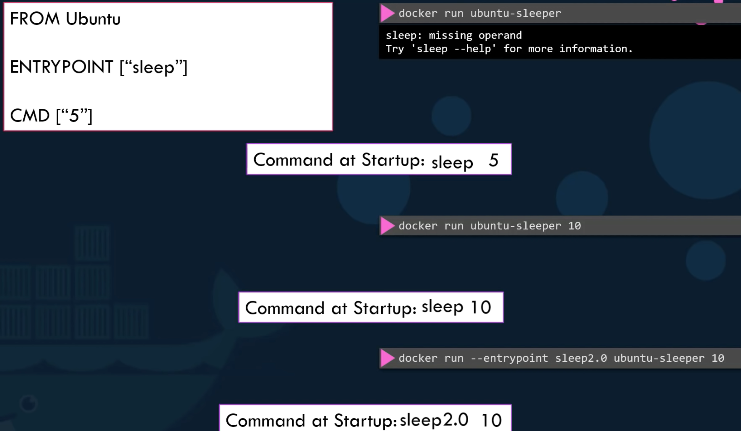

----------------------------------------------------------------------------------------------------

## Docker NETWORKING:

When installed, Docker creates 3 networks automatically .

BRIDGE: default.

NONE: run in an isolated network

HOST: container share the same port as the docker host, so only one port can be used for only one container.

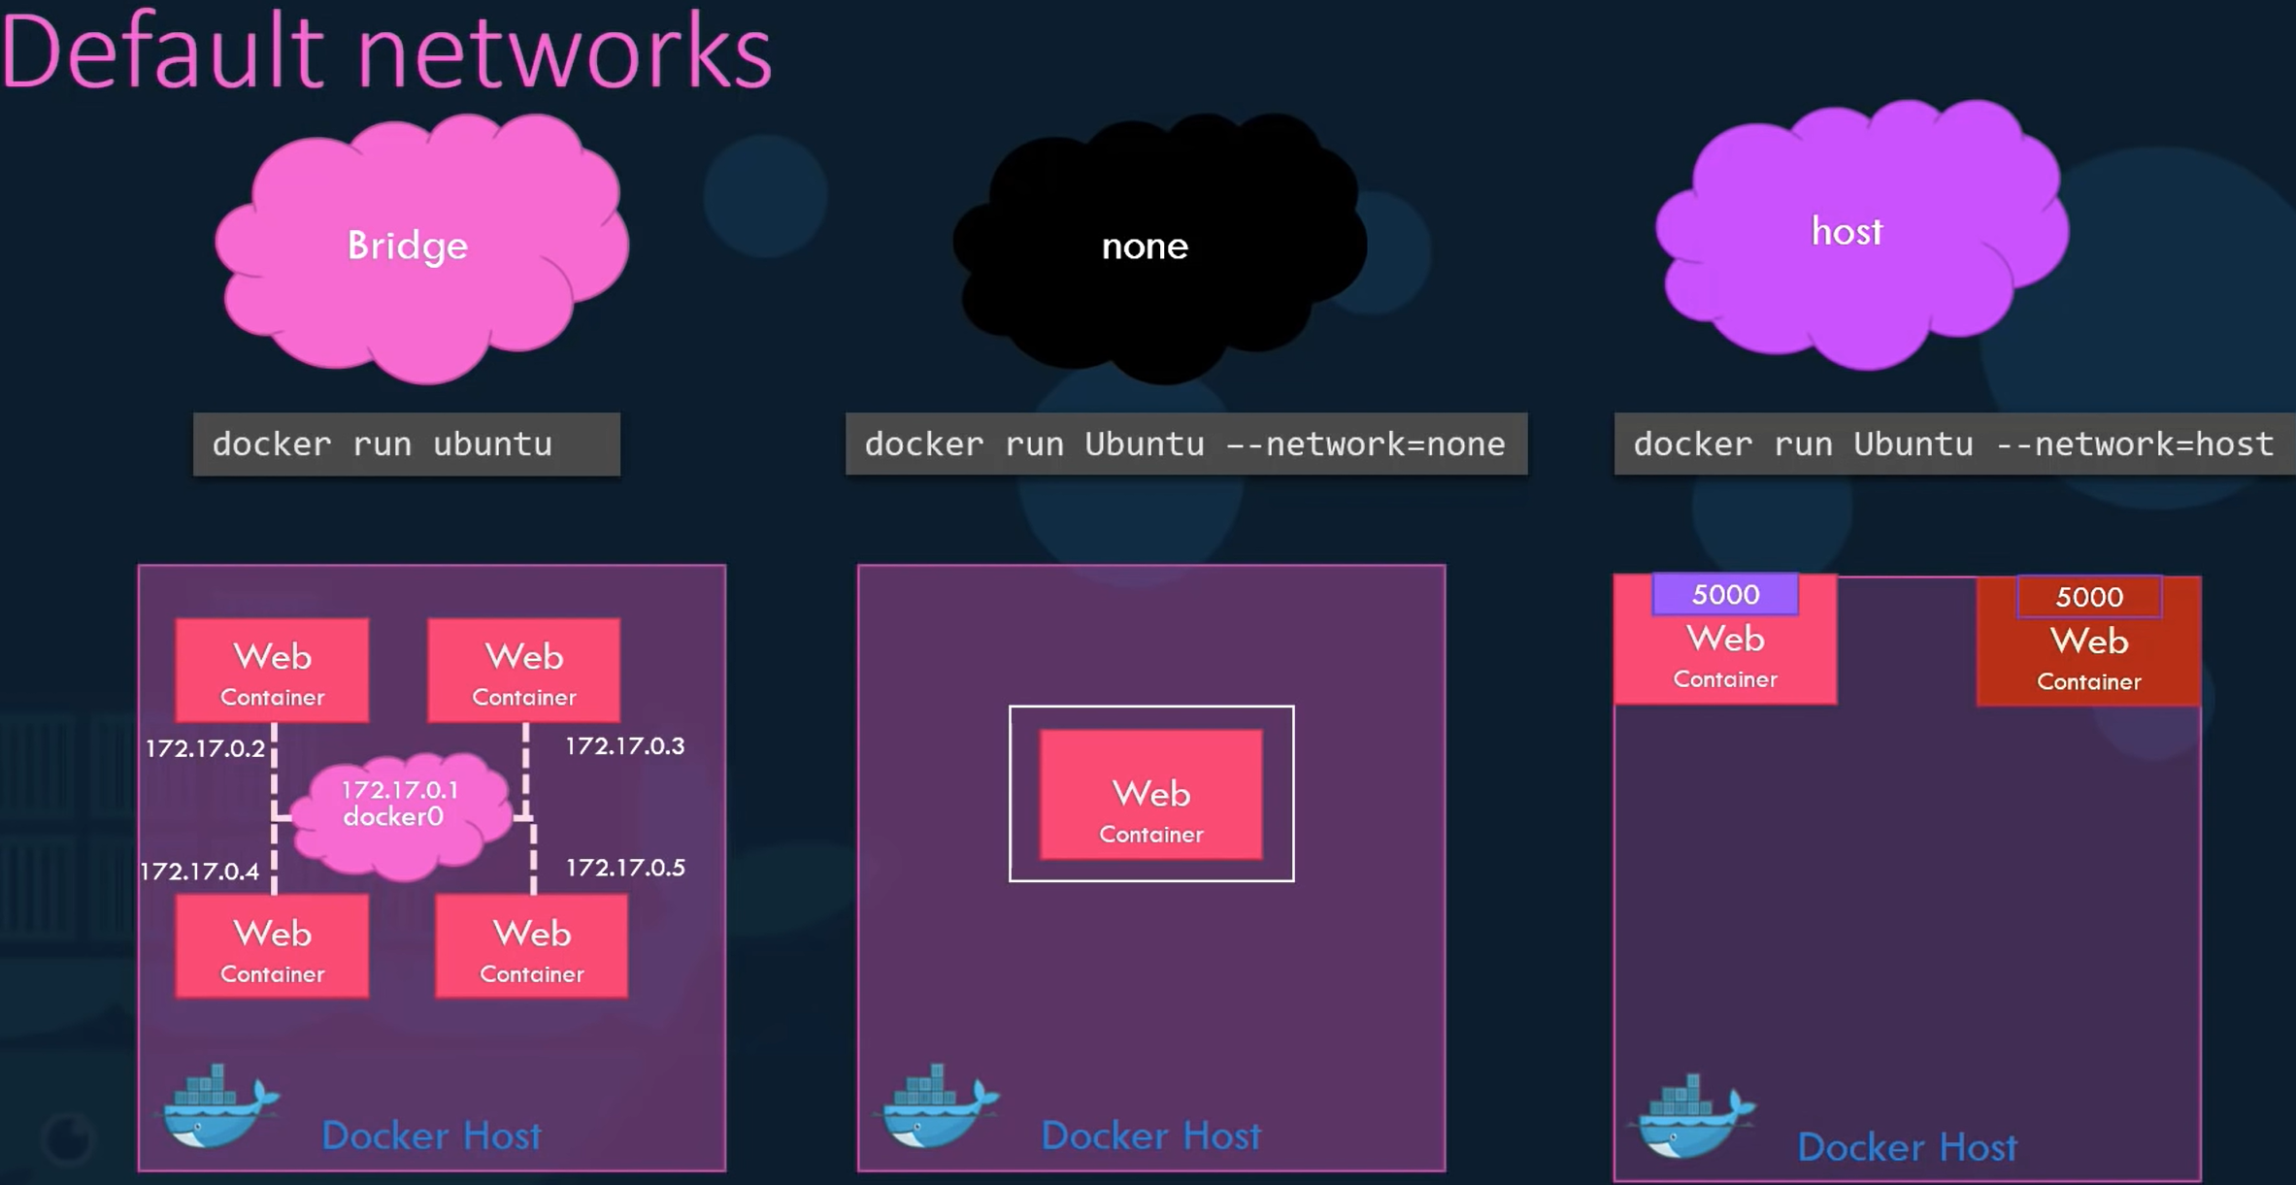

COMMANDS:

**ls** - To list all networks: “ docker network ls ”

**Inspect** network: “ docker inspect *id_or_name_of_container* ” - will have a section on ‘network settings’

Embedded DNS:

** All container in a docker host can resolve (reach) each other with the container name (with help of docker DNS server), as their IP might not be same each time the system boots.

Docker has a built-in DNS server. It always runs at 127.0.0.11

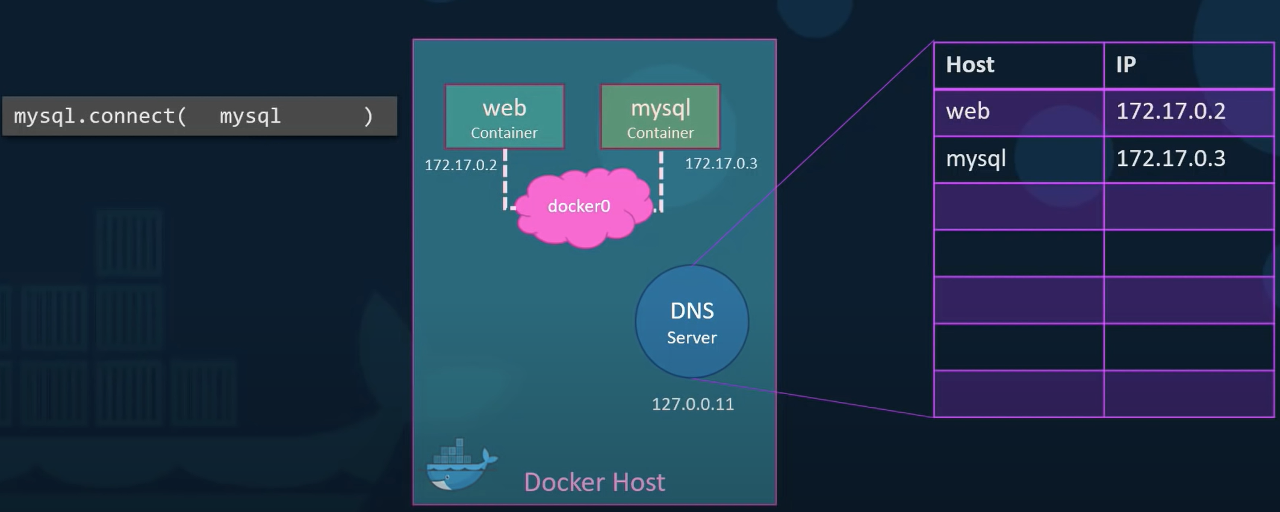

------------------------------------------------------------------------------------------

## Docker STORAGE:

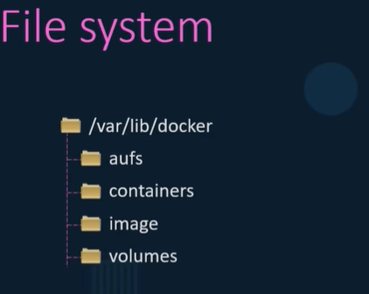

Docker builds images in a Layered Architecture.

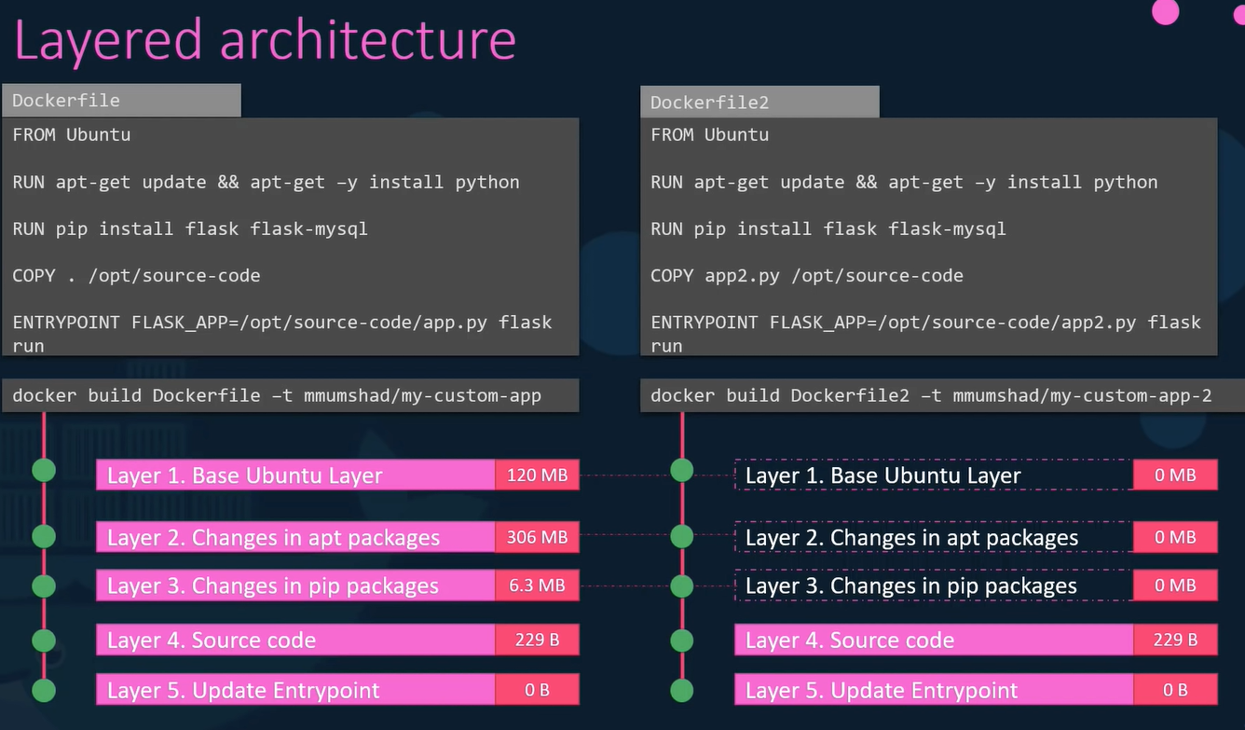

Storage drivers and file systems. : Layered Architecture

Uses ‘copy on write’ mechanism.

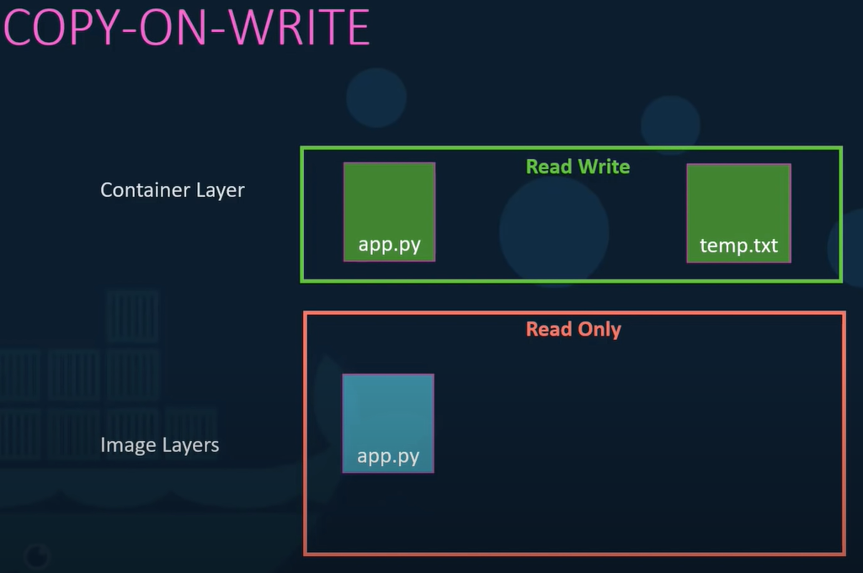

VOLUME MOUNTING:

How to **persist** the data (in the read write above)?

Volumes:

First, Create a ‘volume’ : “ docker volume create *data_volume* ”

TWO types of mounting:

1. Volume mount:

Then mount this volume inside the container while running it:

“ docker run -v *data_volume*:/var/lib/*mysql* *mysql* ” { :/var/lib/*mysql* is the location inside container where container stores data by default }

If not specifically created volume before mounting while running container, docker will create a new volume directory and mount it automatically.

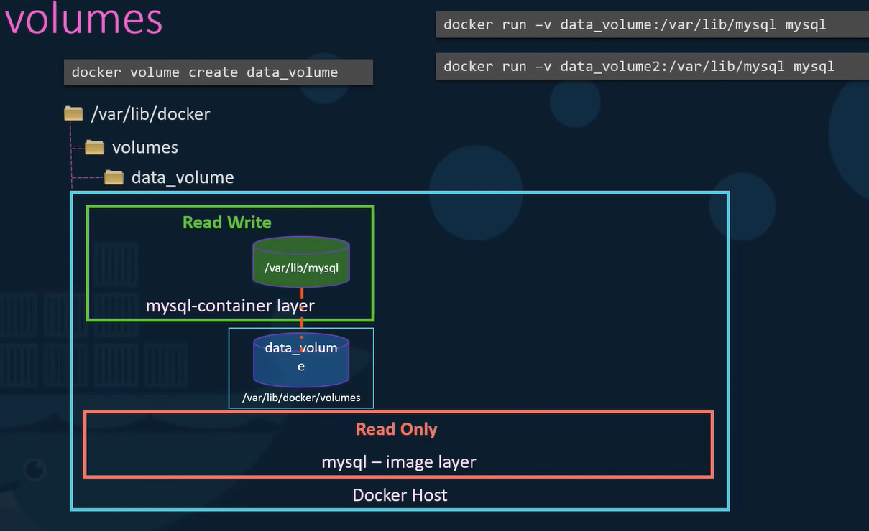

1. Bind mount: mounts dir from any location on docker host

data on already at **another present location** volume on docker host:

Use “ -v ”, but provide complete path to the folder/location we want to mount:

“ docker run -v /data/*mysql*:/var/lib/*mysql* *mysql* ”

** ‘ -v ’ is the old method. New one is “ -mount ” : needs to specify in ‘*key*=*value*’ format:

“ docker run \

--mount type=bind, source=/data/*mysql*, target=/var/lib/*mysql* *mysql* ”

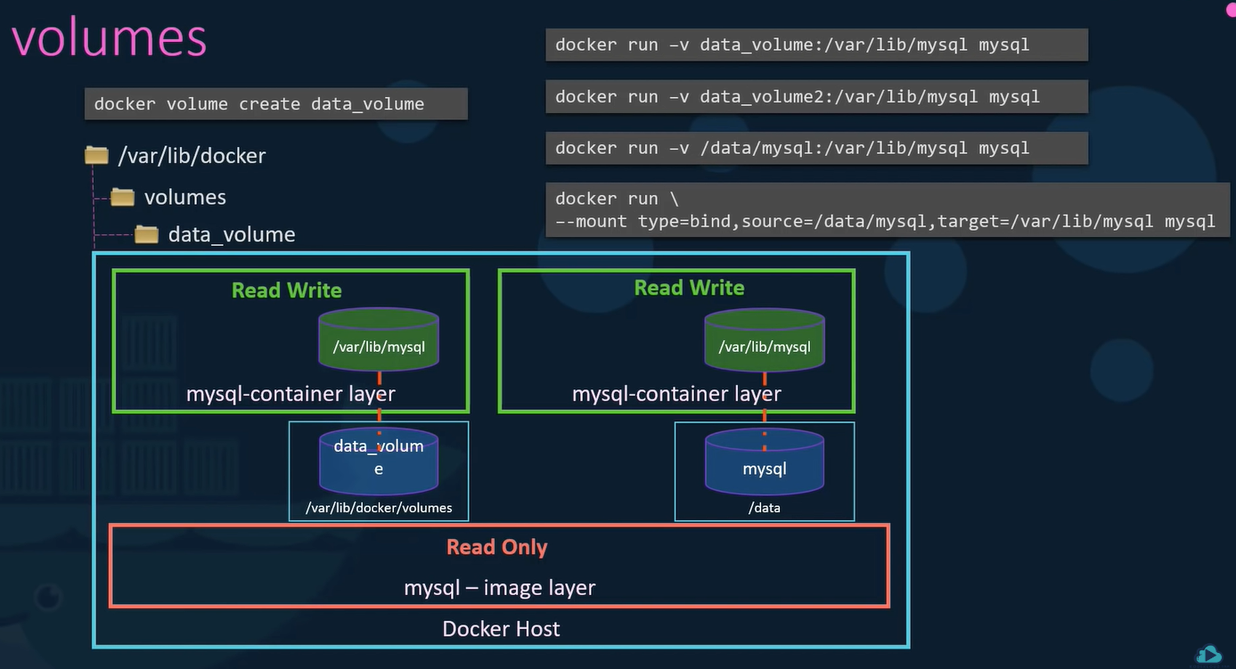

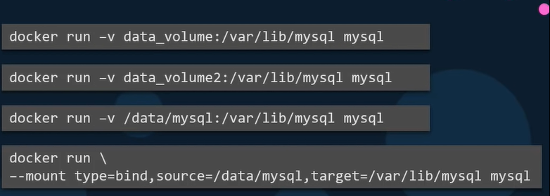

Storage drivers do all this work. Docker uses the best available option based on the OS.

-----------------------------------------------------------------------------------------------

## Docker COMPOSE:

- Use DOCKER COMPOSE: to Run an application using multiple services.

- Configurations in “.yml” files.

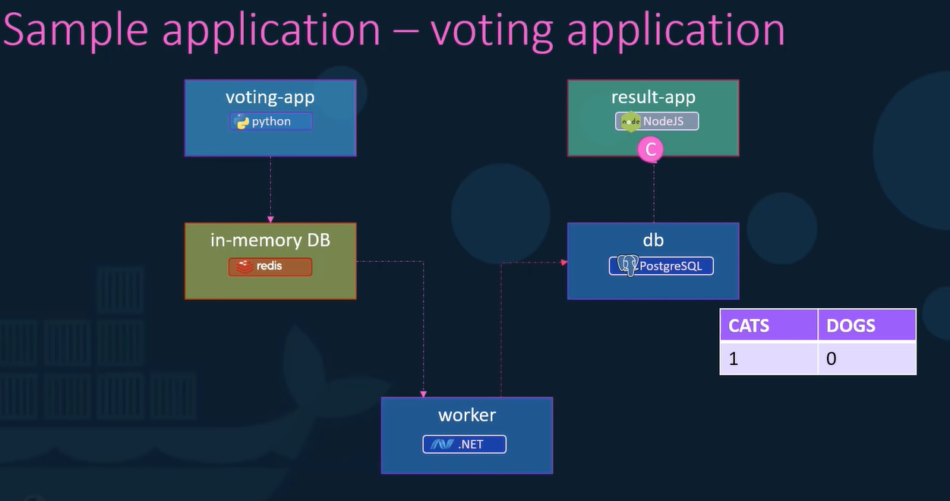

First approach: using ‘Docker run’

Assume that all images are built and available.

Naming the containers is important.

First, Run each container in the background:

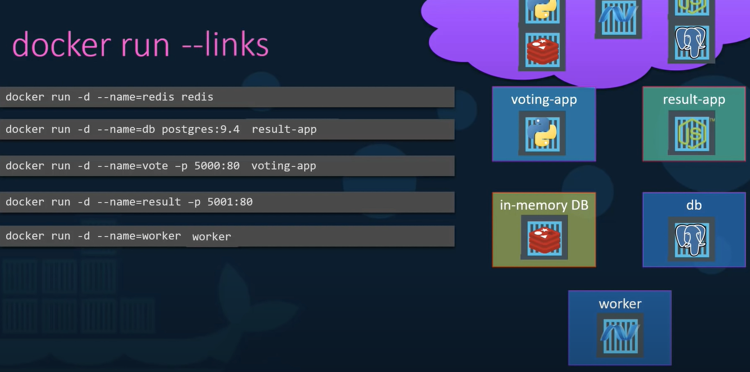

Then, connect the containers to each other using ‘**links**’

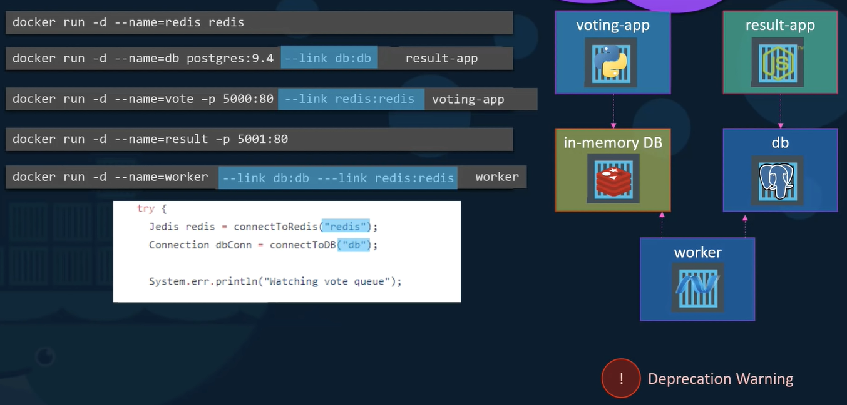

For link, --link *name_of_redis_container***:***name of the host voting app is looking for*

**Using ‘ --link ‘ is deprecated, and may be removed.

After ’run commands’ are tested and ready: DOCKER COMPOSE from it.

“ Docker-compose.yml “

Start with dictionary of container names:

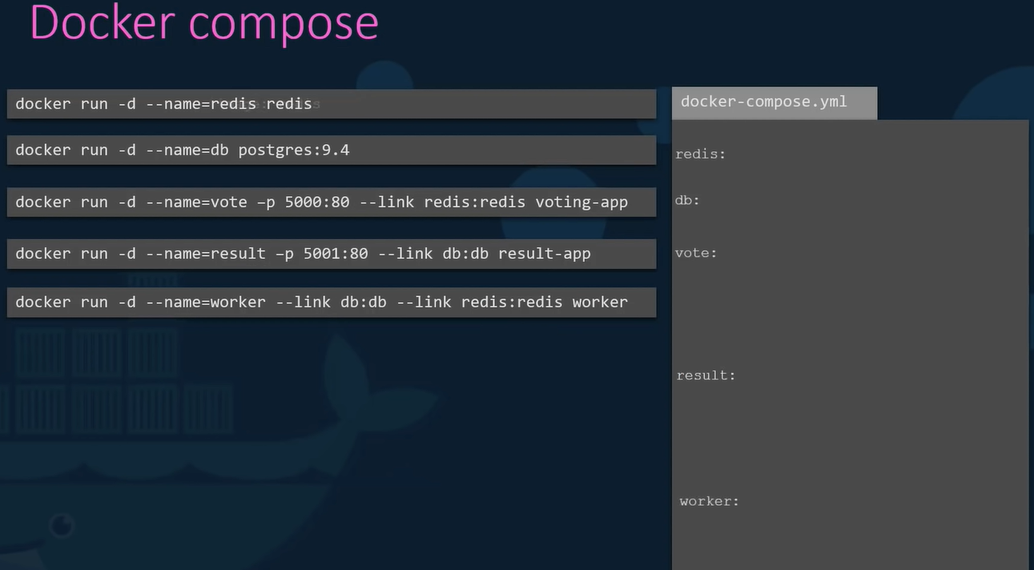

under each key is a nested dictionary starting with a key-value pair of image and their names.

Next, move to other options used in the run docker approach.

Eg:

1. Ports: 2) Links 3)

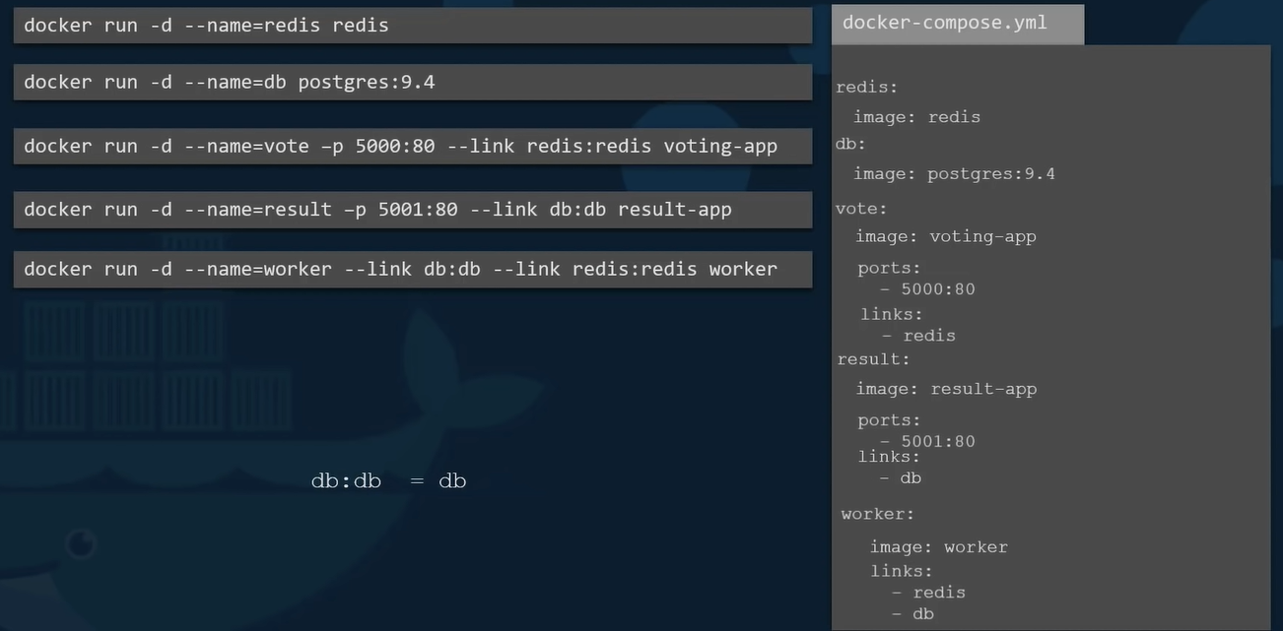

After compose file is ready:

To bring up the entire stack : “ docker-compose up ”

DOCKER COMPOSE - BUILT:

Building the images used in the docker compose above:

If we need docker compose to run a docker built instead of trying to pull an image:

Replace the ‘image’ line with ‘built’ line and Provide location with dir containing application code and a docker file with instructions to build a docker image.

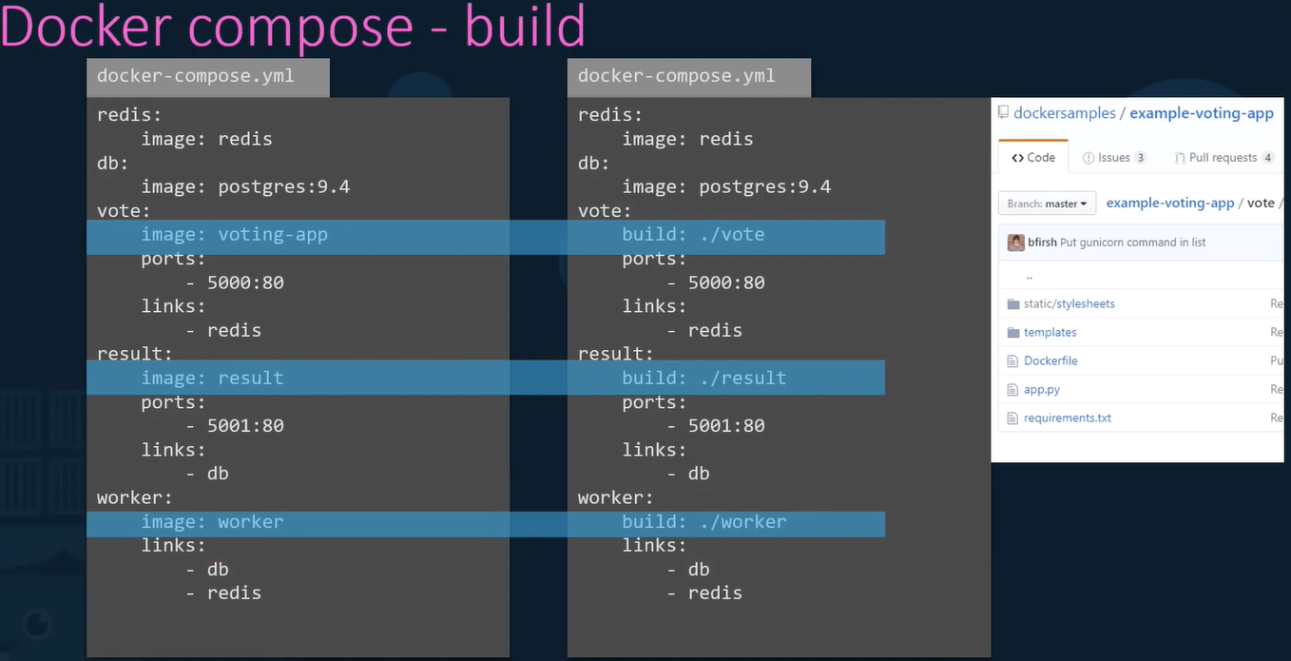

Docker compose - VERSIONS:

Docker has had many versions over the years and versions of development, with changing formats. So, docker-compose files can look very different sometimes.

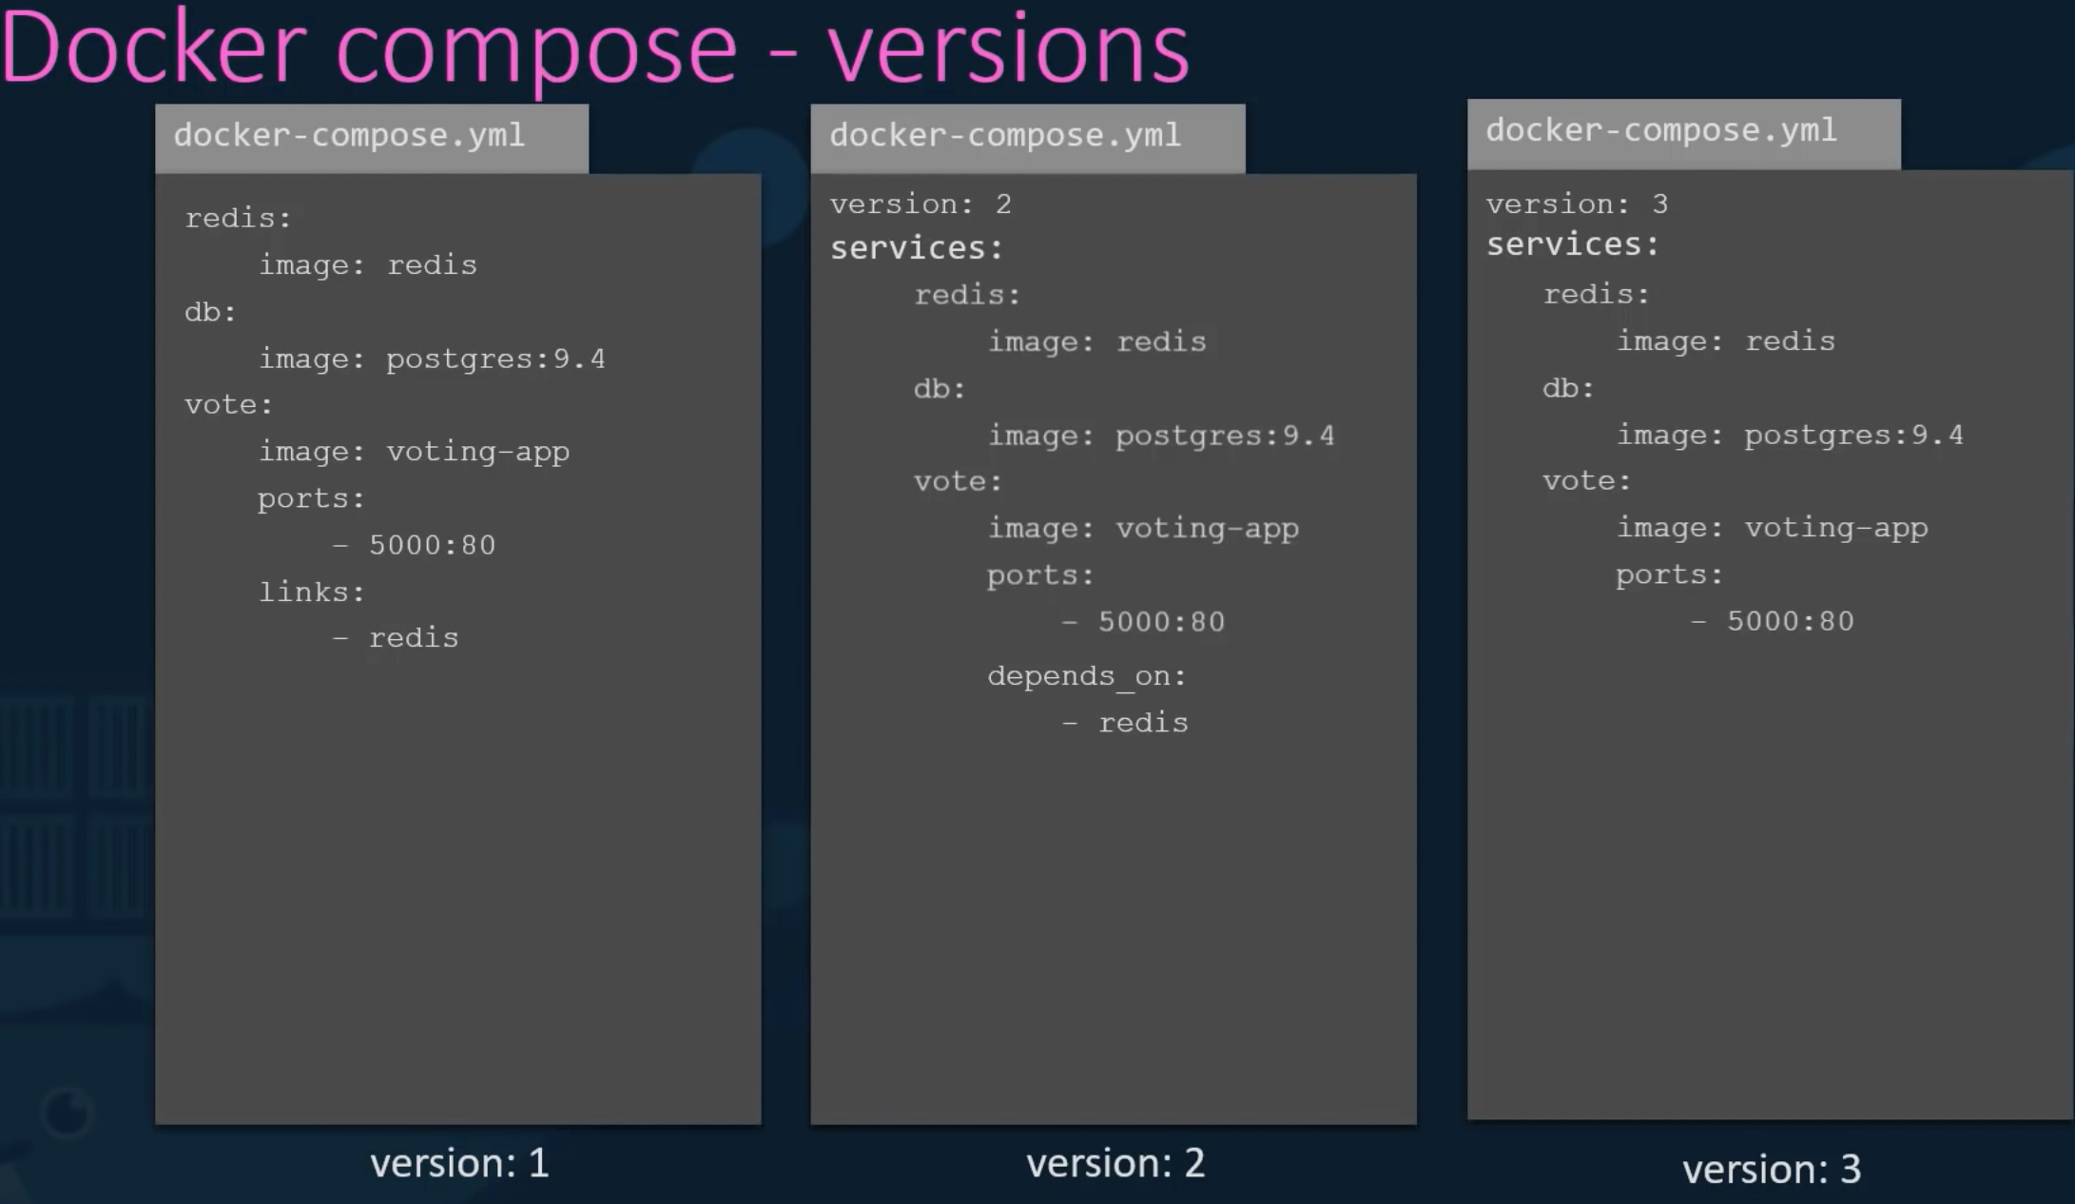

Docker Compose: NETWORKS:

Use separate frontend and backend networks to reduce traffic.

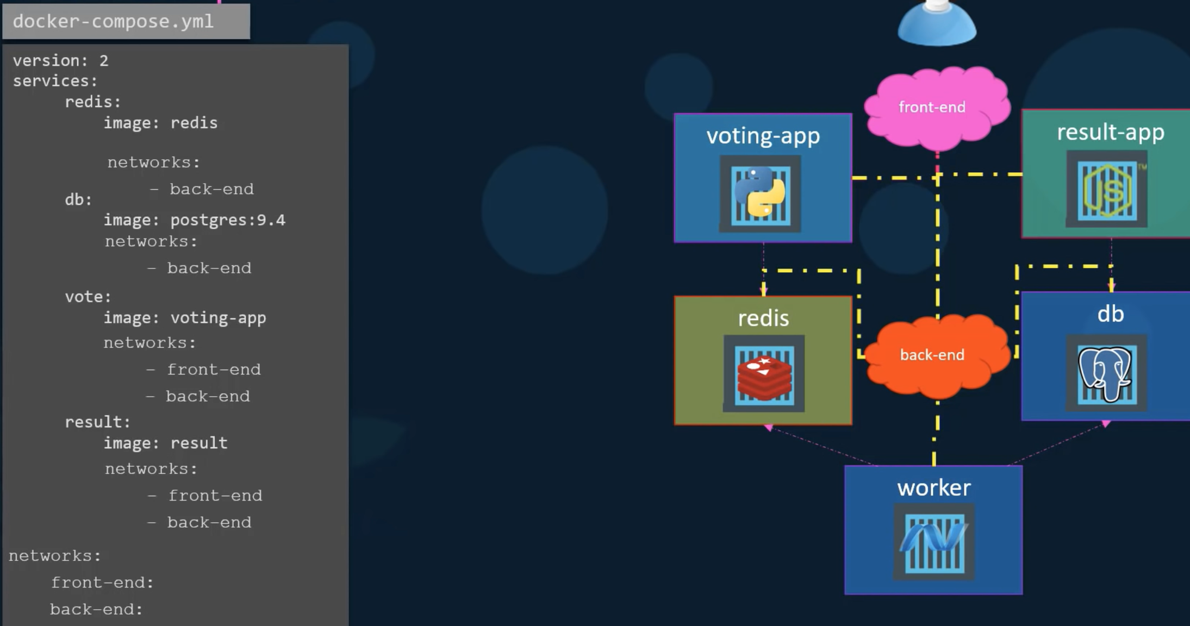

*omitted content from yml file here

-------------------------------------------------------------------------------------------------------

## Docker REGISTRY:

What is a registry?

A registry is a storage and content delivery system, holding named Docker images, available in different tagged versions.

A registry is a storage and content delivery system, holding named Docker images, available in different tagged versions.

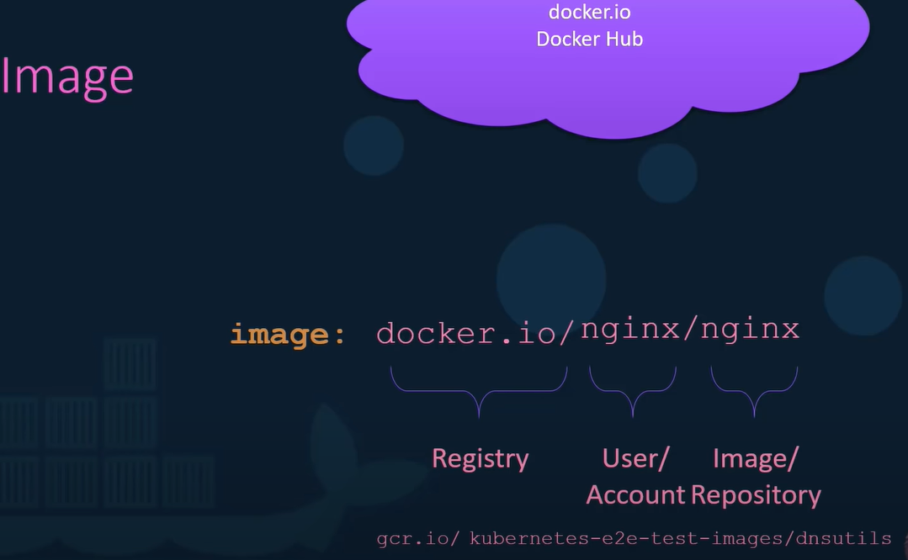

PRIVATE REGISTRY:

*always login before pulling or pushing to a private registry. Otherwise, ‘image not found’ error.

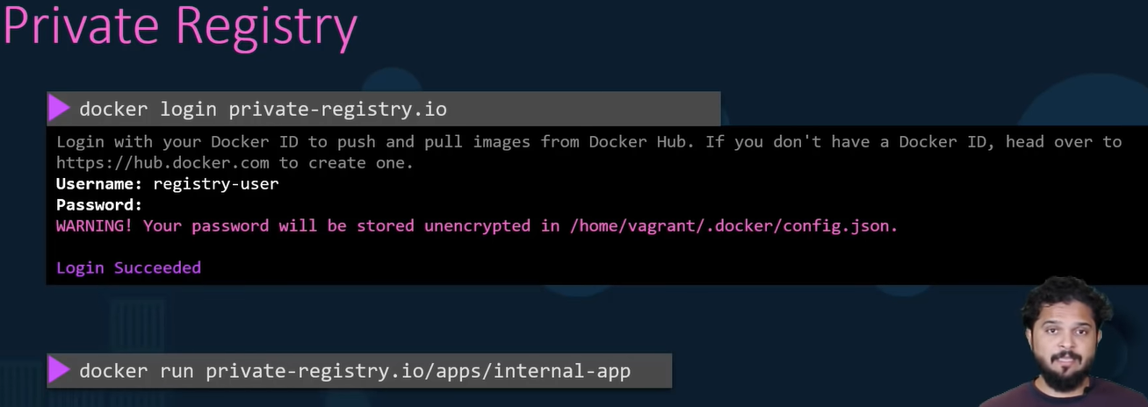

DEPLOY:

Running applications on premise and don’t have a private registry.

Then, how to **deploy** (your own private registry) within your own Organization?:

Docker Registry is itself an application and available as an image named registry, exposes the API on port 5000.

**image tag** - tag the image with a private registry URL in it.

“ docker image tag my-image localhost:/5000/*my-image* ”

Then, Push my image to the local private registry. “ docker push localhost:5000/*my-image* ”

The, can be pulled anywhere.

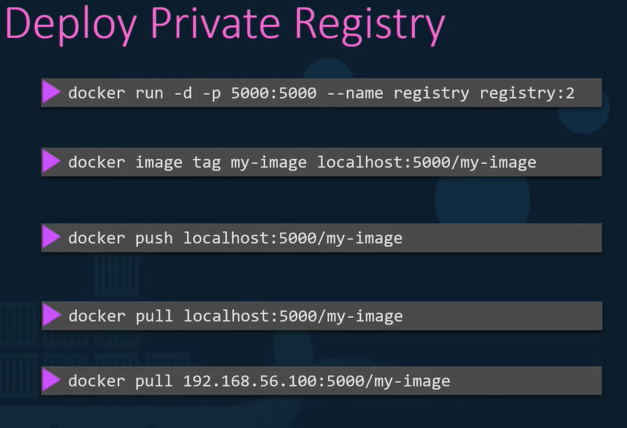

----------------------------------------------------------------------------------------------------

## Docker ENGINE:

Simple the host with docker installed on it.

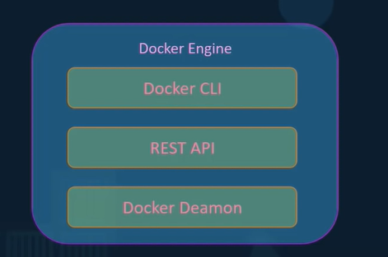

Architecture

CLI can be on a different system:

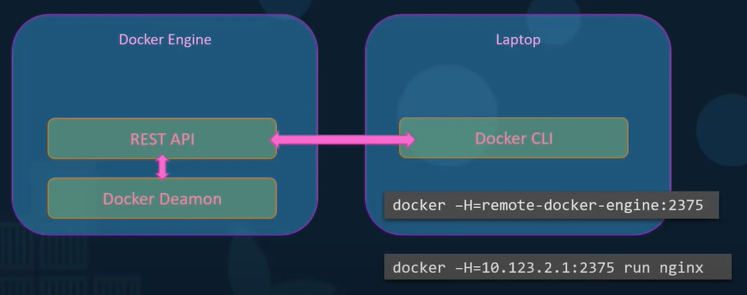

Docker uses namespaces to isolate workspace.

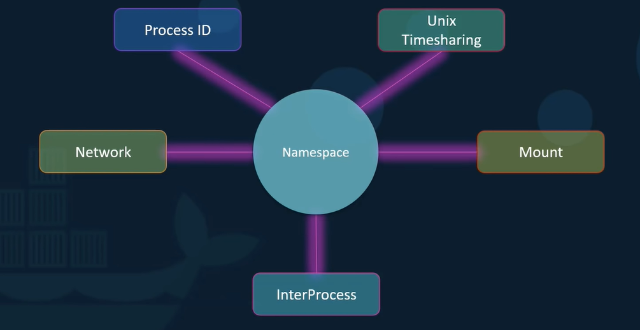

Namespace isolation technique example:

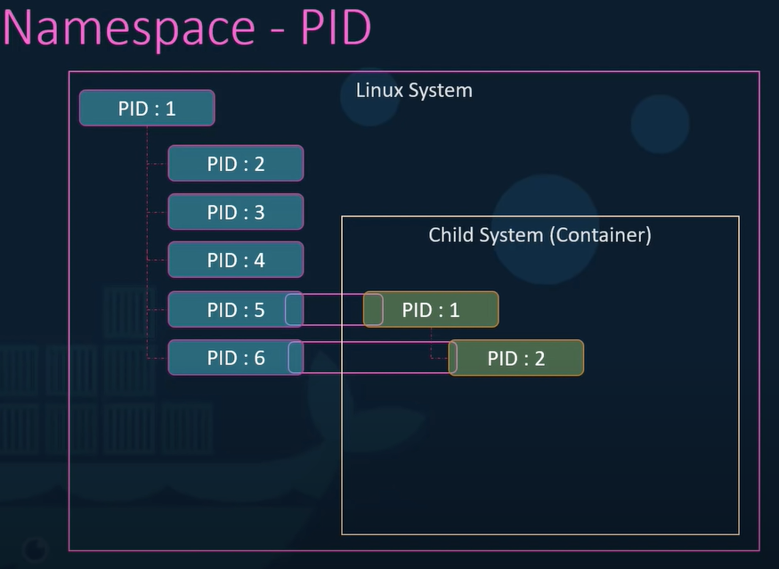

Resource sharing for the host, containers etc can be preset using “cgroups”:

No restriction on resource use by default.

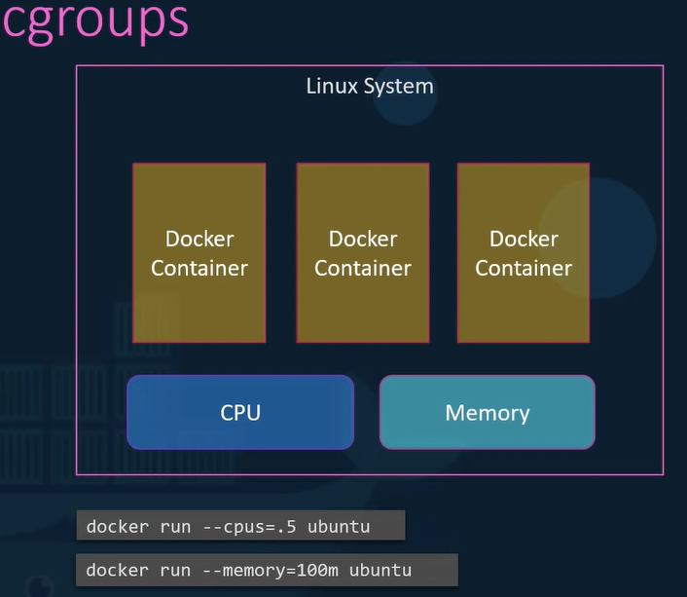

-------------------------------------------------------------------------------------------------------

## Docker on WINDOWS:

TWO options

1. Docker toolbox and 2) Docker desktop for windows.

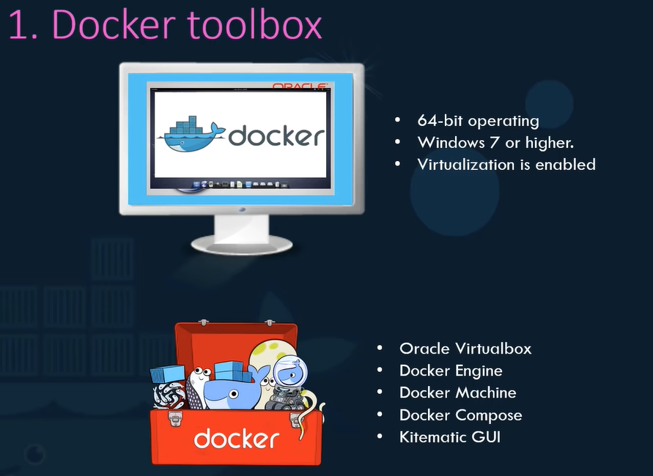

One is the old option (legacy) and for mainly old Windows that don’t meet new requirements

**all this is for linux containers, linux applications packaged into linux images. Not talking about windows applications, windows images, or windows containers.

This is only for: “Linux containers on windows host”.

2016: MS support for windows containers for 1st time.

*Now, package Windows applications into windows docker containers and run on windows docker host, using ‘Docker Desktop for Windows’.

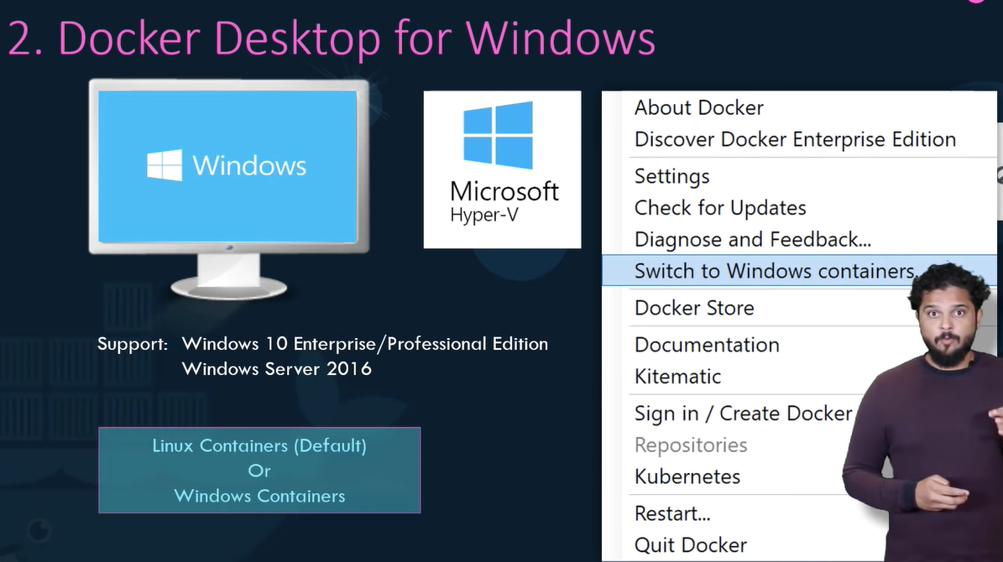

**The default docker for windows installation works with linux containers. Explicitly configure docker to switch to using windows containers.

WINDOWS CONTAINERS: Types:

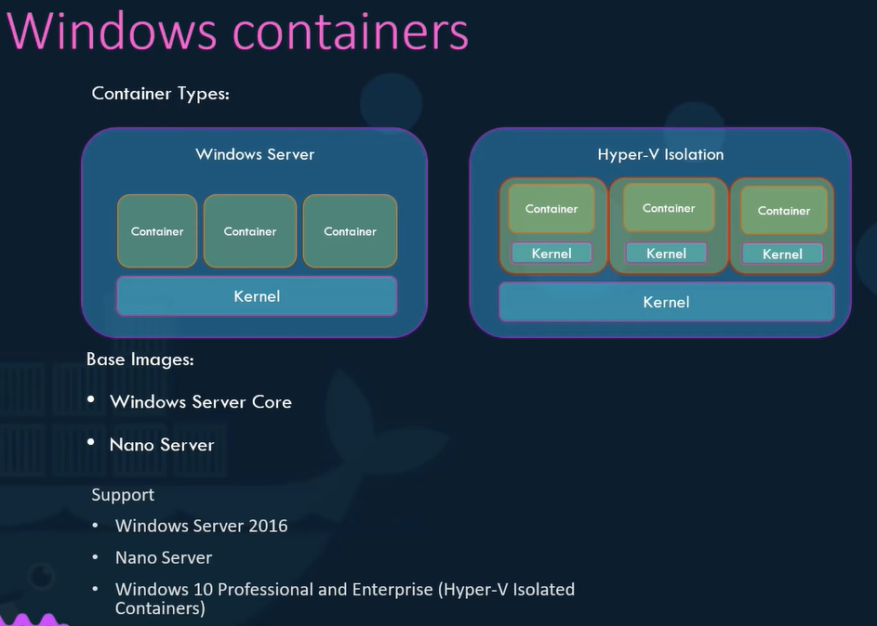

*Windows 10 P and E only supports hyper-v isolated containers.

*VirtualBox and Hyper-V cannot coexist on same windows host

---------------------------------------------------------------------------------------------------------------

## Docker on MAC:

<https://youtu.be/zJ6WbK9zFpI?t=6769>

---------------------------------------------------------------------------------------------------

Container Orchestration:

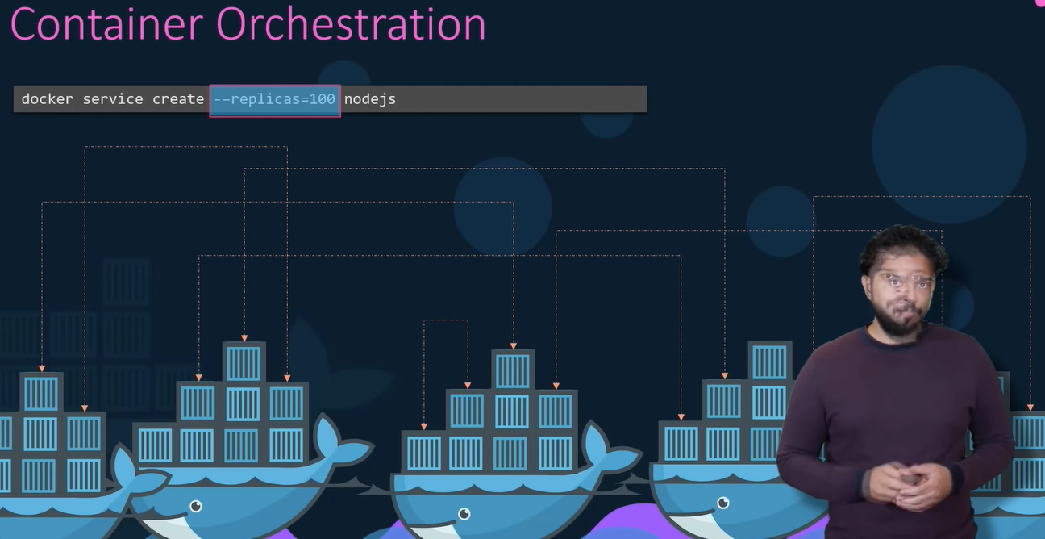

Docker SWARM: easy to set-up and get started. But lacks some of advanced autoscaling features.

MESOS: difficult to set up.

KUBERNETES: most popular. Really good features.

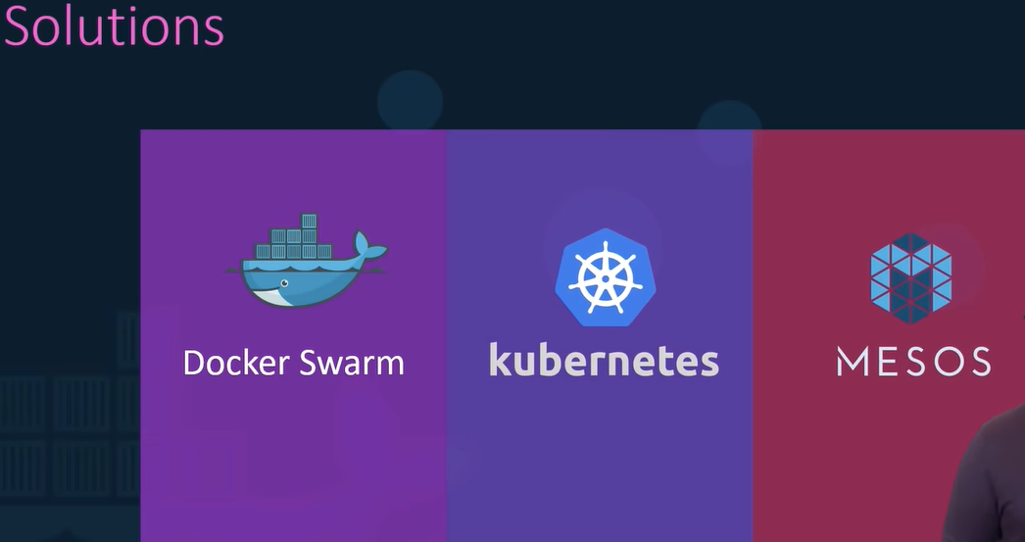

-----------------------------------------------------------------------------------------------------------------

## Docker SWARM:

Can combine multiple docker machines together, into a single cluster.

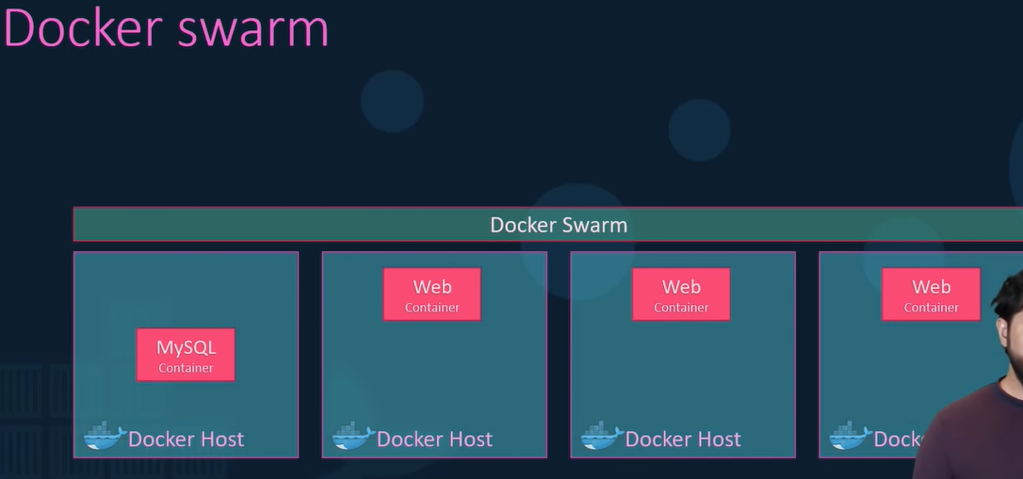

High availability and load balancing.

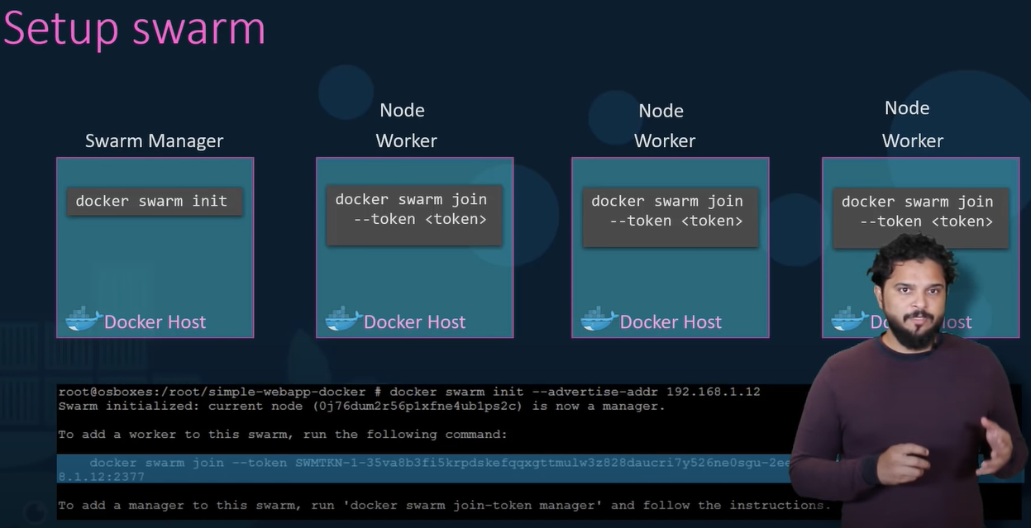

Key component of swarm orchestration: “**Docker Services**”

*docker services are one or more instances of a single application or service that runs across nodes in the swarm cluster. Eg:

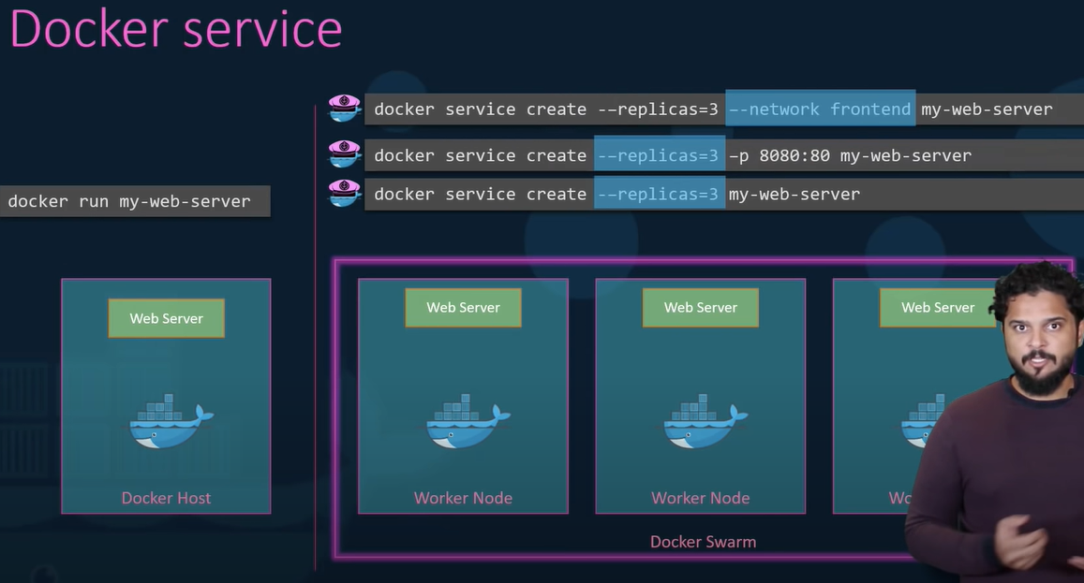

Docker service command is run on the manager node, not on the service node.

--------------------------------------------------------------------------------------------------------

## KUBERNETES:

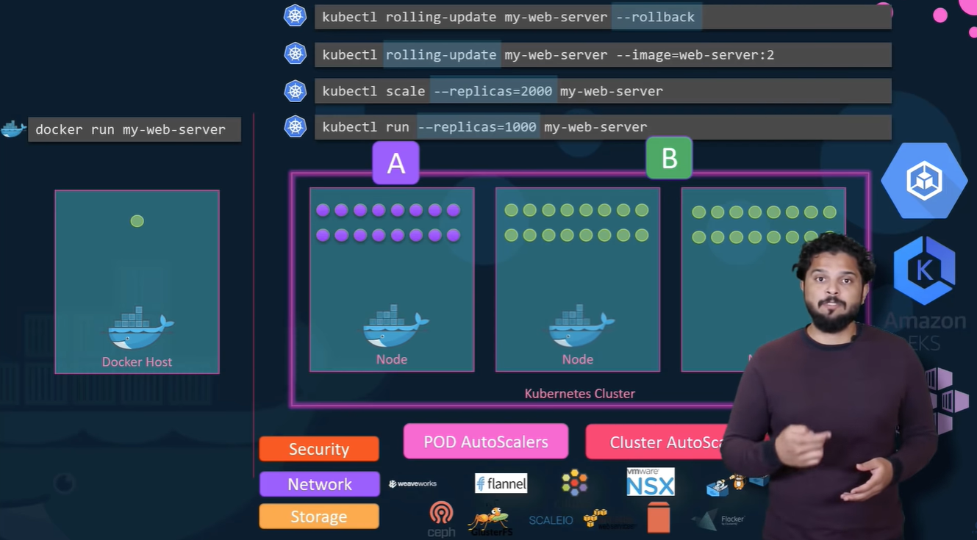

Kubernetes Architecture:

Nodes: a physical machine where kubernetes sits

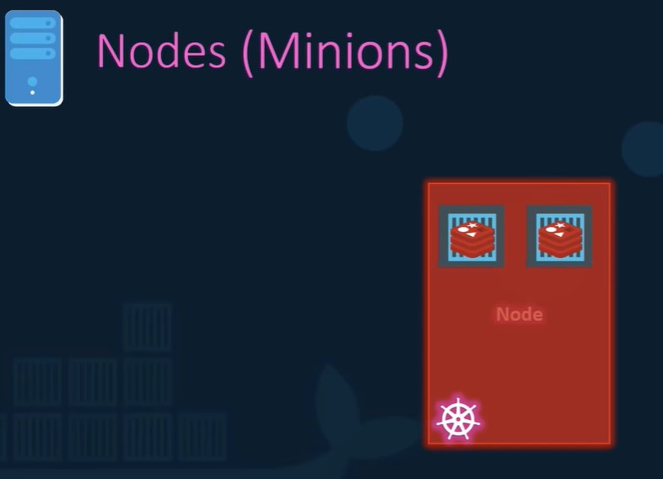

Cluster: a set of nodes:

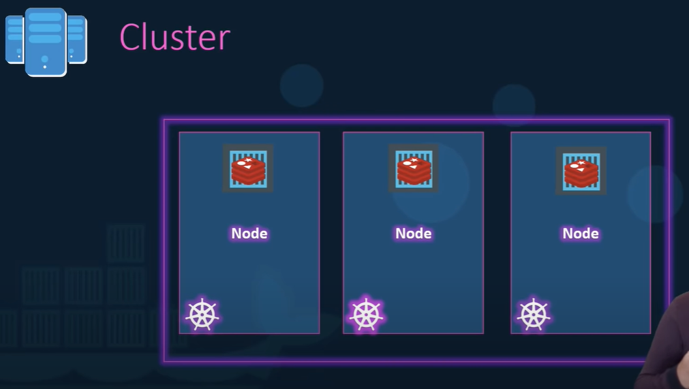

Master:

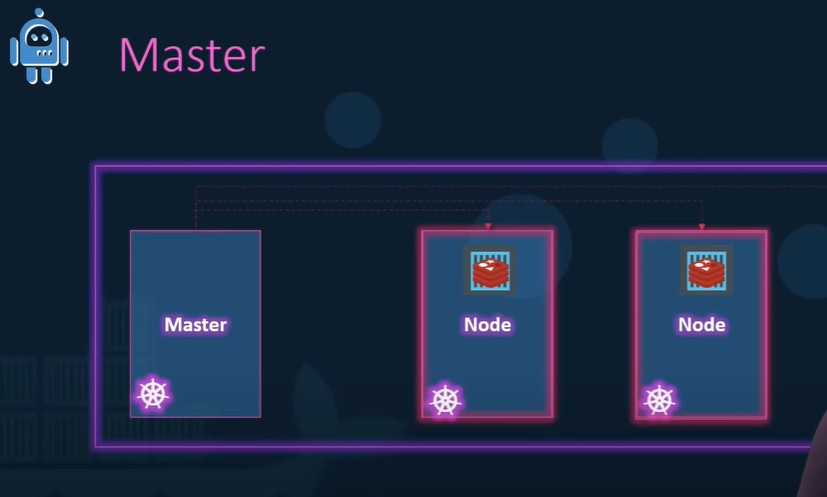

Components:

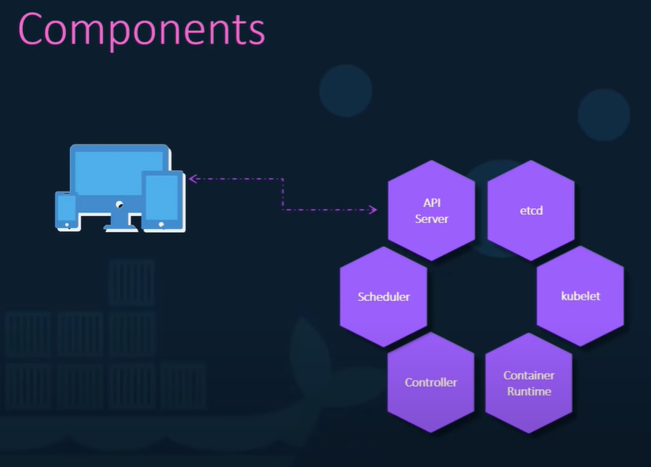

Command line utility: “ kubectl ”

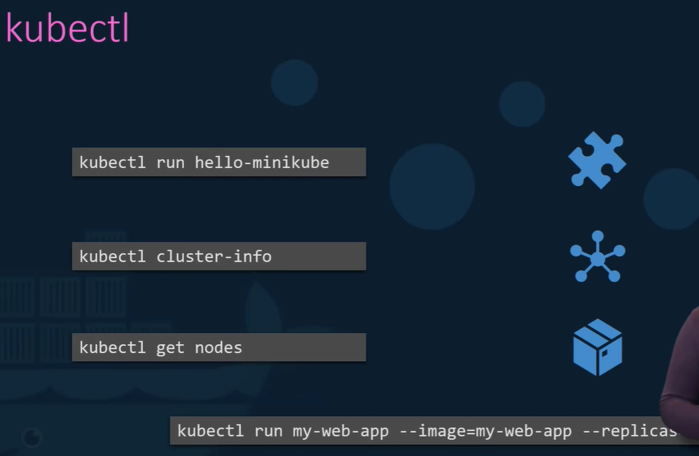

REF (same as beginning): <https://youtu.be/zJ6WbK9zFpI>

========================================================================

###########################################################################